Title of Manuscript:
Role of Fine-Needle Aspiration Cytology in Evaluation of Breast Lumps
Ashish Koshti, Maneesh Sulya, Reeni Malik
Department Of Pathology, Gandhi Medical College, Bhopal, M.P.

ABSTRACT
Background: Breast lump is most common presentation in most of the breast diseases. Fine-Needle Aspiration Cytology (FNAC) is the immediate tool of the physician when first time patient is examined. The method is rapid, accurate, minimally invasive and serve as a therapeutic procedure when a cyst is encountered.
Method: This is a retrospective hospital based study conducted at department of Pathology,Gandhi Medical College, Bhopal over a period of two and a half years. It included 531 patients with breast lump attending the outpatient department (OPD).
Result: FNAC was done on 531 cases of breast lump, 31 (5.84%) cases were not satisfactory and remaining 500 (94.16%) were satisfactory enough for a cytological diagnosis. Out of 500 cases, benign lesions were 358 (71.60%), malignant lesions were 87 (17.40%), inflammatory lesions were 41 (8.20%) and suspicious category include 14 (2.80%). Fibroadenoma was the most common benign lesion and ductal carcinoma was the common malignant lesion. The sensitivity, specificity, positive predictive value, negative predictive value and accuracy of FNAC was 98.13%, 100%, 100%, 98.98% and 99.34% respectively.
Conclusion: FNAC of the breast lump is a simple, safe, economical, and rapid diagnostic procedure which can be used routinely on OPD basis, because the cytopathological examination of these lesions before operation or treatment serves as an important diagnostic modality.
Keywords: FNAC, breast lesions, fibroadenoma, ductal carcinoma.

Introduction:
All breast lesions are not malignant, and all the benign lesions do not progress to cancer; however the accuracy of diagnosis can be increased by a combination of preoperative tests (like physical examination,mammography, fine-needle aspiration cytology, and core needle biopsy). These modalities are more accurate, reliable, and acceptable when compared with a
single adopted diagnostic procedure despite of having their own technical limitations .^{[1, 2]}
Most common symptoms associated with breast lesions reported by women are pain, palpable
mass, lumpiness without a palpable mass or nipple discharge.^{[3]} A breast mass is generally
palpable when it exceeds 2cm in size. The likelihood of a palpable mass being malignant increases with age. Only 10% of breast masses under the age of 40 are malignant compared to 60% of masses over the age of 50 years.^{[3]}
Fine-needle aspiration (FNA) is an established and highly accurate method for diagnosing breast lesions. The use of core biopsy (CB) is being increasingly advertised but its procedure is more cumbersome, expensive and time consuming as compared to FNA procedure.^{[4–6]} Core Biopsy or tru cut needle biopsy is not widely used because of its complications, interpretation, and time-consuming results; therefore palpable breast lesions can be accurately diagnosed by triple test only (FNAC, physical examination and Mammography).^{[7]}
It has been shown that, FNAC can reduce the number of open breast biopsies.^{[8]} FNAC has been found to have sensitivity ranging from 82% to 97.5% and specificity of more
than 99% .^{[9,10,11]}
The adequacy of FNAC is dependent on multiple factors. The rate of inadequate aspiration ranges from 0.7% to 25.3% , and this is influenced by the nature of the lesion, the available technology, and the experience and preference of the operator. ^{[12]} It was reported that the nature of the lesion was the most common cause of inadequacy of FNAC, accounting for 68% of the inadequate aspirates, followed by the experience of the aspirator that accounted for 32% of the inadequacy rate. ^{[13]} Some studies advocated that both aspirator and interpreter should ideally be the same, as the number of inadequate aspirates was far lower and the accuracy of diagnosis was higher when the same person aspirated and reported on the specimens. ^{[12, 14, 15]} The National Cancer Institute (NCI) definition of adequacy was one that led to resolution of a problem presented by a lesion in a particular patient’s breast. ^{[16]} Nevertheless, many authors considered epithelial cell clusters as the most important adequacy criteria. Studies demonstrated that an appropriate number of epithelial cell clusters could be an important factor in lowering the false-negative diagnosis rate in palpable and nonpalpable breast masses. ^{[17,18]} It was further suggested that a cut-off of six epithelial cell clusters may provide a reasonable balance between reduction of false-negative FNAC smears and an increase in the rate of inadequate smears. ^{[18]} Since diagnosing malignancy involves evaluation of the cytologic features of the epithelial cells, quantification of epithelial cells in the smears is most likely helpful. ^{[17]}
Standard reporting system for breast FNAC, In the UK National Health Service Breast
Screening Programme (NHSBSP) guidelines use a C1–C5 system: C1, inadequate; C2, benign; C3, atypical, probably benign; C4, suspicious; and C5, malignant. So that we find that the C3 and C4 categories always go to biopsy, be it core biopsy (CB) or otherwise. ^{[19,20]}
Most of the institutions in the USA follow the National Cancer Insistute (NCI) consensus conference recommendations belonging to the following categories: unsatisfactory, benign, atypical, suspicious and malignant. ^{[21]}

FNAC breast reporting categories, as listed in the European and USA guidelines:

NHSBSP (UK), 2001 ^{[19]}
European Guidelines ^{[22]} NIH recommendations (USA) ^{[21]}

C1 Unsatisfactory Unsatisfactory
C2 Benign Benign
C3 Suspicious, probably Atypical ⁄ indeterminate
benign

C4 Suspicious, probably Suspicious ⁄ probably
Malignant malignant
C5 Malignant Malignant

The present study was undertaken to evaluate frequency, cytomorphological variations, and clinical presentation of different breast lesions.

Material and Methods:
A retrospective hospital based study was conducted at the pathology department, Gandhi Medical College, Bhopal, India. Data was collected from the records of FNAC of breast
lesions done in last two and half year duration. All the fine needle aspiration (FNA) was carried out with a 22 or 23 gauge needle attached to a 20 cc airtight disposable syringe fitted
in a syringe holding FNA gun which provided a better grip and a negative pressure to aspirate adequate sample. The sample was obtained by to and fro motion. Samples were smeared onto glass slides just previously smeared with albumin for cellular adhesion; a thin smear was made and the slide was fixed immediately in 95% methanol. In cystic lesions, after aspiration of fluids, the lesion was again aspirated. The fluid was centrifuged and smears are made from sediment. Wet-fixed smears were stained with Haematoxylin and Eosin (H&E), and Papanicolaou stain. FNAC results were studied in detail for findings of inflammatory, benign breast lesions, suspicious and malignant lesions.
Result:
GRAPH NO. 1: AGE INCIDENCE

AGE: FNAC of palpable breast lesions was done in different age group ranging from 11 yrs 80 yrs and the mean age was 34.33 yrs.

Table No.1: Age incidence
 | Age Group | Number of Cases | Percentage (%)
1 | 0-10 | 00 | 00
2 | 11-20 | 74 | 13.94
3 | 21-30 | 191 | 35.97
4 | 31-40 | 139 | 26.18
5 | 41-50 | 63 | 11.86
6 | 51-60 | 15 | 2.82
7 | 61-70 | 32 | 6.03
8 | 71-80 | 17 | 3.20
 | Total | 531 | 100.00

It is find decade (21-30) showed maximum number of breast lesion (35.97%) while no case was found in the first decade.
Table No.2 : Side Of Involvement
LOCATION:-
In the present study, 45 patients (8.47%) presented with bilateral lesions, where as 486 patients presented with unilateral involvement of the breast.
Sr. No. | Side | Number of Cases | Percentage (%)
1 | Right | 217 | 40.87
2 | Left | 269 | 50.66
3 | Bilateral | 45 | 8.47
 | Total | 531 | 100

Majority of the lumps 269 (50.66%) were located in left breast and 217 (40.87%) were located in the left breast.

GRAPH NO. 2 : INVOLVEMENT OF DIFFERENT QUADRANTS

Among the quadrants majority of the lumps 302 (56.88%) were located in upper outer quadrant, followed by upper inner quadrant which constituted 87 cases (16.38%) and rest as shown in the (Table No.3).
Table No.3: Involvement of different quadrants
Sr.No. | Quadrant | Number of Cases | Percentage (%)
1 | Upper outer | 302 | 56.88
2 | Upper inner | 87 | 16.38
3 | Lower outer | 85 | 16.01
4 | Central | 40 | 7.53
5 | Lower inner | 17 | 3.20
 | Total | 531 | 100

GRAPH NO. 3 : CATEGORIZATION OF VARIOUS LESIONS OF BREAST

Table No.4: Categorization Of Various Lesions Of Breast
Lesions | Number of Cases | Percentage (%)
Inflammatory | 41 | 8.20
Benign | 358 | 71.60
Malignant | 87 | 17.40
Suspicious | 14 | 2.80

Out of 500 cases, inflammatory lesion were 41 (8.20%) benign lesions 358 (71.60%) and malignant lesion 87 (17.40%) with suspicious category 14 (2.80%) .

GRAPH NO. 4 : CATAGORIZATION OF INFLAMMATORY LESIONS OF BREAST

Table No.5: Categorization of inflammatory lesions of breast
Benign Lesions | Number of Cases | Percentage (%)
Mastitis | 36 | 87.80
Abscess | 3 | 7.32
Granulomatous | 1 | 2.44
S/o Epithelial Hyperplasia | 1(False Negative ) | 2.44

Amongst inflammatory lesion, mastitis was commonest with 36 cases (9.02%) followed by Abscess 3 (0.75%) A single case of granulomatous lesion and epthelial hyperplasia was encountered in this category of inflammatory lesions.

GRAPH NO. 5 : CATAGORIZATION OF BENIGN LESIONS OF BREAST
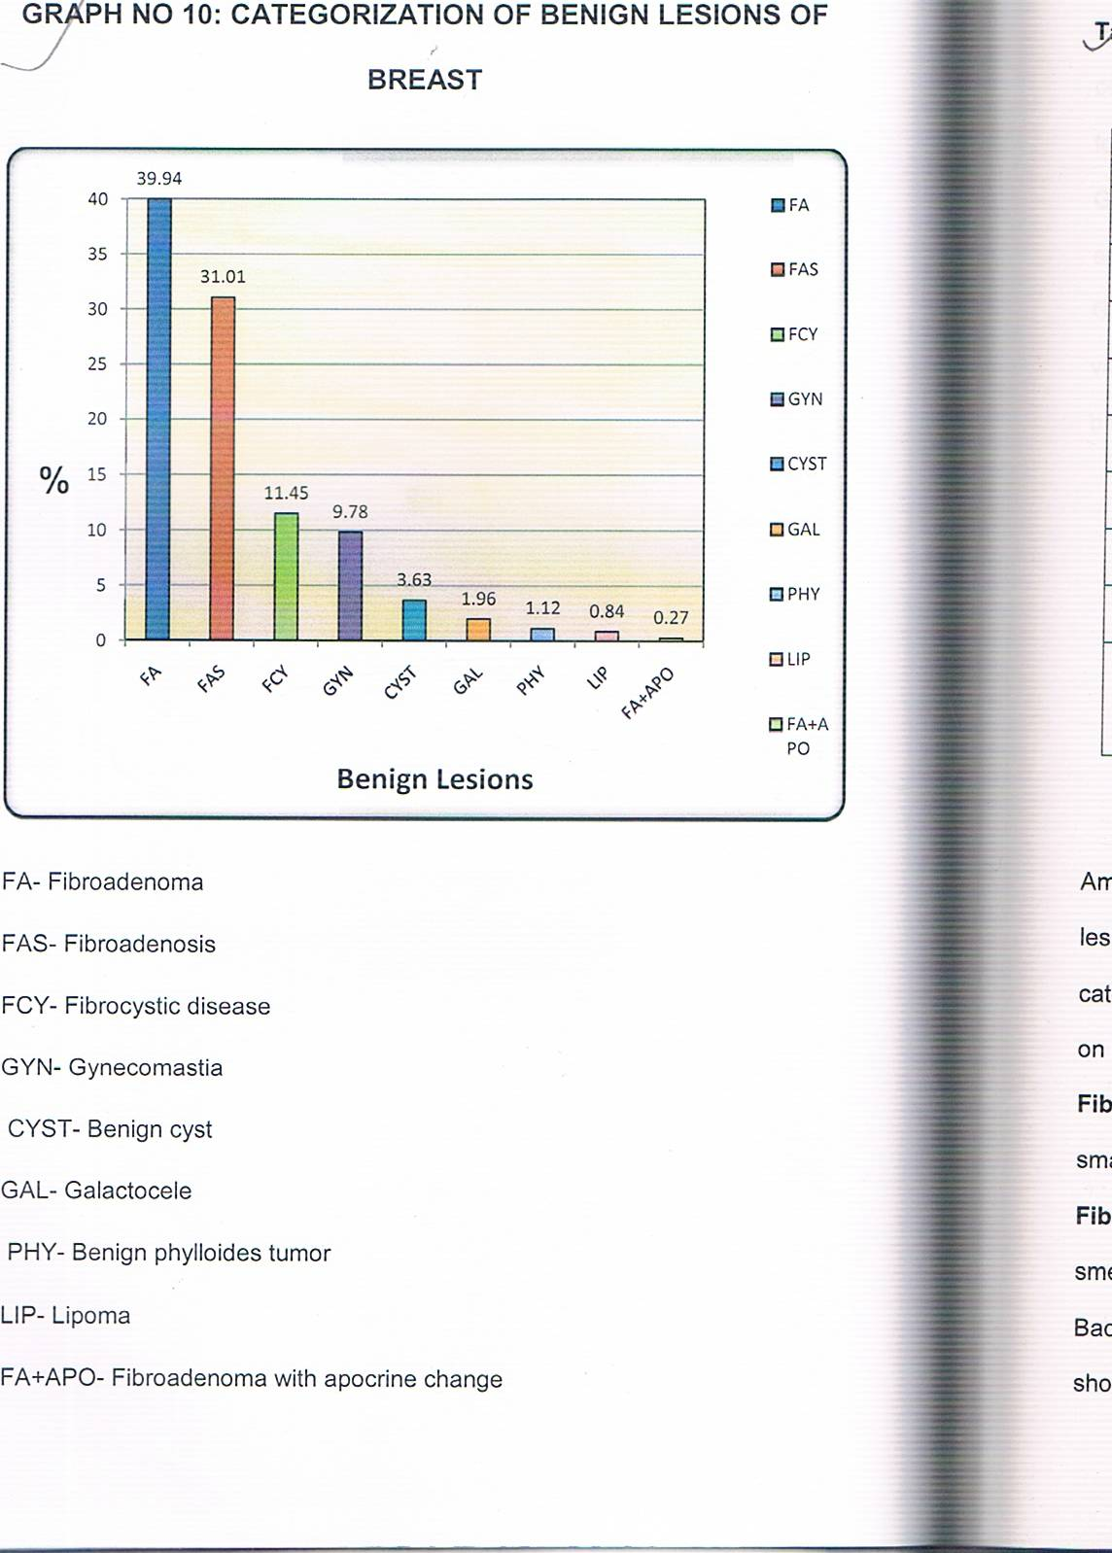

Table No. 6: Categorization of benign lesions of breast
Benign Lesions | Number of Cases | Percentage
Fibroadenoma | 143 | 39.94
Fibroadenosis | 111 | 31.01
Fibrocystic disease | 41 | 11.45
Gynecomastia | 35 | 9.78
Benign cyst | 13 | 3.63
Galactocele | 7 | 1.96
Benign phylloides tumor | 4 | 1.12
Lipoma | 3 | 0.84
Fibroadenoma with Apocrine cell change | 1 (False Negative ) | 0.27

Amongst Benign lesions, Fibradenoma (39.94%) was the most common lesion, followed by fibroadenosis and fibrocystic disease. This benign category also includes two false negative cases which proved to be malignant on histopathology.
Fibrocystic disease: Smear showed cyst macrophages, bare nuclei and small groups of benign ductal epithelial cells and RBCs in all cases.
Fibroadenoma:- The aspirate was whitish granular in these cases. Cellular smears showed benign duct epithelial cells in tight cohesive clusters. Background was formed by bare nuclei and stromal fragments. A few cases showed apocrine changes and antler horn pattern.

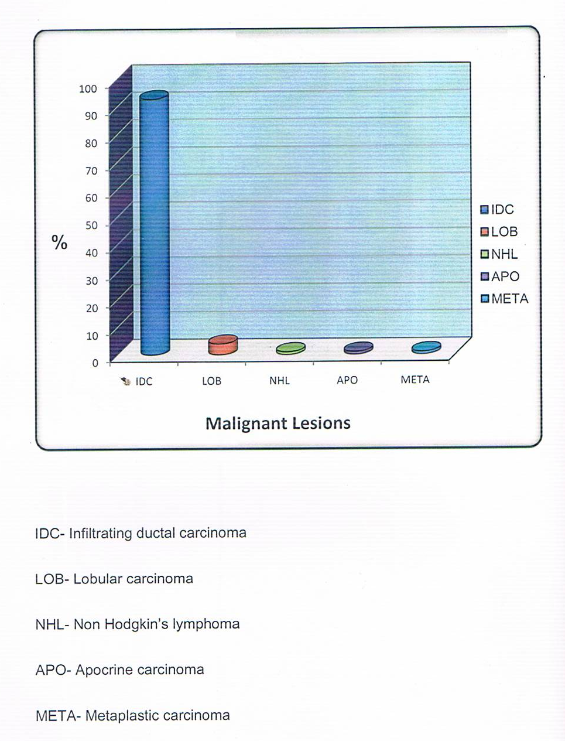
GRAPH NO. 6: CATEGORIZATION OF MALIGNANT LESIONS OF BREAST

Table no. 7: Categorization of malignant lesions of breast.
Malignant Lesion | Number of Cases | Percentage
Infiltrating carcinoma | 94 | 93.07
Lobular carcinoma | 4 | 3.96
Non Hodgkin's lymphoma | 1 | 0.99
Apocrine carcinoma | 1 | 0.99
Metaplastic carcinoma | 1 | 0.99

Out of 101 malignant lesions, 94 were infiltrating duct carcinoma (93.07), 4 were Lobular carcinoma (3.96%) and 1(0.99%) each of Apocrine carcinoma, Metaplastic carcinoma and Non-Hodgkin's lymphoma.
Infiltrating ductal carcinoma: Smear showed malignant cells with hyperchromatic nuclei and prominent cytoplasm. A few cases showed mitotic figures, multinucleate.
Invasive Labular carcinoma: Smear showed Indian file arrangement of malignant cells with poorly cohesive cluster s. Also there was intra cytoplasmic neolumina.
Metaplastic carcinome: Smear showed high celluarity of fragments of fibromyxoid stroma containing spindle cells with nuclear pleomorphism and hyperchromasia. Also showed tumor giant cell.
Non- Hodgkin's lymphoma: Cellular smear showed proliferation of lymphocytes with mixture of centrocytes and centroblasts having round, irregular and cleaved hyperchromatic nucliei with scanty cytoplasm.
Apocrine carcinoma: Smear showed malignant cells both individually scattered and arranged in syncytial fragments having apocrine features.
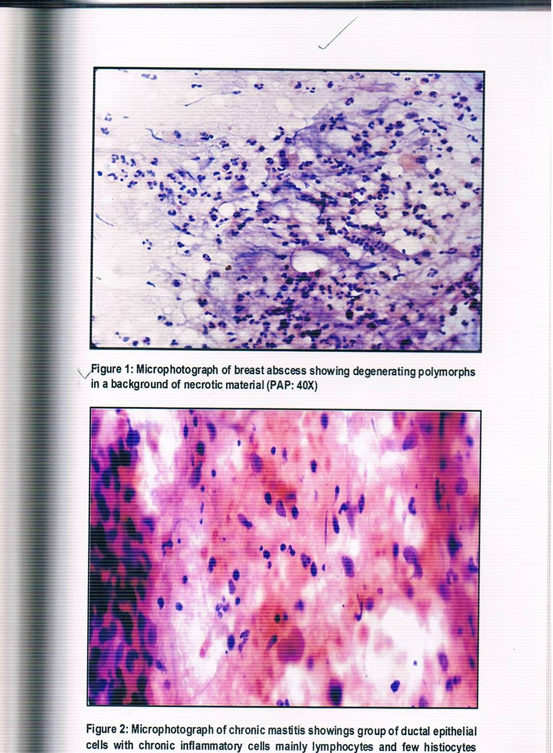

Figure 3: Microphotograph of Fibroadenoma showing apocrine changes (PAP : 40X)
Fig. 4 : Microphotograph of Fibroadenoma showing Antier horn pattern.

Fig. 5: Microphotograph of Invasive duct carcinoma showing dispersed malignant cells.

Fig. 6: Microphotograph of Invasive duct carcinoma showing dispersed malignant cells
with multinucleation.

Fig.7: Microphotograph of infiltrating lobular carcinoma showing typical Indian File of
malignant cells with poorly cohesive clusters ( PAP: 40X).
Fig.8: Microphotograph of infiltrating lobular carcinoma showing intracytoplasmic neolumina
with poorly cohesive clusters of malignant cells.

Discussion:
Table No. 1: Side of involvement (in Percentage)
Sr. No. | Author | Right | Left | Bilateral | Total
1 | Ahmed et al (2010) | 43.0 | 51.0 | 6.0 | 200
2 | Sandhu et al (2010) | 47.4 | 51.6 | 1.0 | 267
3 | Present study | 40.87 | 50.66 | 8.47 | 531

In the present study, left breast was more commonly involved than the right breast. Similar finding were found in studies of Ahmed et al ^{[23]} and Sandhu 49 et al ^{[24]}.
Table No. 2: Presenting quadrants of breast lesions: (In Percentage)
Presenting Quadrants | Zuk et al (1989) | Sandhu et al (2010) | Present study
Upper outer | 42.2 | 47.7 | 56.88
Upper inner | 6.4 | 9.5 | 16.38
Lower outer | 5.3 | 3.6 | 16.01
Lower inner | 4.3 | 1.6 | 3.20
Central | 31.6 | 4.9 | 7.53

Upper outer quadrant was more commonly involved followed by upper inner quadrant which correlated well with the study condructed by Zuk et al ^{[25]} and Sandhu et al ^{[24]}.
Table No. 3: Comparative analysis of Breast Lesions: (In percentage)
Sr.No. | Author | Inflammatory | Benign | Malignant | Suspicious
1 | Pandit et al (1988) | 16.97 | 67.42 | 28.02 | 4.55
2 | G. Jayaram (1996) | 7.4 | 69.7 | 12.2 | 3.3
3 | Singh et al (2001) | 8.5 | 83.33 | 14.58 | 2.08
4 | Choi et al (2004) | 0.77 | 75.6 | 14.0 | 2.9
5 | Pradhan M (2008) | 8.24 | 81.92 | 15.49 | 2.32
6 | Ahmed et al (2010) | 11.00 | 66.00 | 34.00 | 00
7 | Present study | 8.20 | 7160 | 17.40 | 2.80

In the present study inflammatory lesion were well in comparison with those of Singh et al ^{[26]} G. Jayaram ^{[27]} and Pradhan M ^{[28]} .
Benign breast lesions accounted for 71.60% of the cases (358 cases), and this finding is comparable with finding of G. Jayaram ^{[27]} , Choi et al ^{[29]} and Pandit et al ^{[30]}.
Malignant lesions accounted for 17.40% (101 cases) of total cases and there were (14) 2.64% lesions diagnosed as suspicious for malignancy on cytology, these finding are comparable with the finding of the breast of the breast FNAC study reported by Pradhan M ^{[28]} and Singh et al ^{[26]} .
Table No.4: Comparative analysis of benign lesions: (In percentage)
Cytological diagnosis | Singh et al (2001) | Pradhan et al (2008) | Ahmed et al (2010) | Present Study
Fibroadenoma | 48.5 | 8.01 | 28.0 | 39.94
Fibroadenosis | 40.5 | 43.41 | 00 | 31.01
Fibrocystic disease | 00 | 4.27 | 11.5 | 11.45
Gynecomastia | 00 | 2.18 | 1.5 | 9.78
Galactocele | 1.0 | 0.71 | 4.0 | 1.96
Benign phylloides tumor | 00 | 0.18 | 1.0 | 1.12
Benign cyst | 3.0 | 0.09 | 6.0 | 3.63
Lipoma | 00 | 0.31 | 3.0 | 0.84

In the present study, fibroadenoma was the most common benign lesion diagnosed in 39.94% which is in comparison with the study of breast lesion FNAC by Singh et al ^{[26]}. It is followed by Fibroadenosis as second most common benign lesion which is similar finding to that of Singh et al ^{[26]} and Pradhan et al ^{[28]}.
Table No. 5 : Comparative analysis of malignant lesions : (In Percentage)
Cytological diagnosis | Goel et al (2003) | Pradhan et al (2008) | Present study
Infiltrating ductal carcinoma | 90.0 | 97.13 | 94.07
Lobular carcinoma | 2.0 | 0.29 | 04.96
Medullary carcinoma | 2.0 | 0.86 | 00
Mucinous carcinoma | 00 | 0.86 | 00
Non-Hodgkin's lymphoma | 00 | 0.29 | 01.99
Apocrine carcinoma | 00 | 00 | 01.99
Metaplastic carcinoma | 00 | 00 | 01.99
Metastatic | 3.0 | 00 | 00

Out of 500 cases in the present study, malignancy was noted in 101 cases (including 14 cases reported as 'suspicious for malignancy') accounting for 20.20% incidence. Among these 101 cases, 94 were reported as infiltrating duct carcinoma, 4 as lobular carcinoma and 1 each as Apocrine carcinoma, Metaplastic carcinoma and Non-Hodgkin's lymphoma. the incidence of infiltrating ductal carcinoma is similar to studies of Goel et al ^{[31]} and Pradhan et al ^{[28]} .
Table No.6 : Statistical Result- Comparative Analysis
Sr.No. | Study | Sensitivity | Specificity | PPV | NPV | Accuracy
1 | Kapila & Verma (1989) | 97.6 | 99.4 | 99.5 | 97.2 | 98.4
2 | Collaco et al (1999) | 92.1 | 98.6 | 99.4 | 82.1 | -
3 | Choi et al (2004) | 77.7 | 99.2 | 98.4 | 88.0 | 91.1
4 | Q. He et al (2007) | 97.72 | 99.4 | - | - | 97.94
5 | Present study | 98.13 | 100 | 100 | 98.98 | 99.34

PPV= Positive predictive value
NPV= Negative predictive value
In the present study Sensitivity is 98.13% Specificity 100.00% Positive predictive value 100.00% Negative predictive value 98.98% and Overall accuracy 99.34%.
Sensitivity and Specificity are similar to Kapila and Verma et al ^{[32]} and Q. He et al ^{[33]}.
Whereas Positive and Negative Predictive value is similar to Kapila and Verma et al ^{[32]}.
Conclusion :
The fine needle aspiration cytology of the breast lumps is a simple, safe and rapid diagnostic procedure which can be used routinely on OPD basis.
The main purpose of FNAC of breast lumps is to confirm cancer preoperatively and to avoid unnecessary surgery in specific benign conditions. A diagnosis of malignancy allows pre-operative discussion on available therapeutic option.
The benign breast lesions were far more common than the malignant breast lesions.
Abbreviations :
FNAC – Fine Needle Aspiration Cytology
OPD - Outpatient department
CB - Core Biopsy
NCI - National Cancer Institute
NHSBSP - National Health Service Breast Screening Programme
NIH - National Institutes of Health
PPV - Positive predictive value
NPV - Negative predictive value

Acknowledgment:
I find myself with paucity of words to express my gratitude and thankfulness to Dr. Reeni Malik, HOD Department of Pathology, GMC, Bhopal. Her affection and moral support anchored me to get this paper done.
I begin by expressing my sincere thanks to Dr. Maneesh Sulya, Assistant Professor, Department of Pathology, GMC, Bhopal, for the help provided in completing this paper.
Declarations:
Funding: No funding sources
Conflict of interest: None declared
Ethical approval: The study was approved by the Institutional Ethics Committee.

References:
1. M. Auger and I. Huttner, “Fine-needle aspiration cytology of pleomorphic lobular carcinoma of the breast: Comparison with the classic type,” Cancer, vol. 81, no. 1, pp. 29–32, 1997.
2. M. H. Bukhari and Z. M. Akhtar, “Comparison of accuracy of diagnostic modalities for evaluation of breast cancer with review of literature,” Diagnostic Cytopathology, vol. 37, no. 6, pp. 416–424, 2009.
3. Susan C. Lister. The Breast. In, Kumar, Abbas, Fausto, Aster(Ed). Robbins and Cotran Pathologic basis of disease.8th edition. Philadelphia, Pensylvania, Saunders,2010;1066-8.
4. M. Rubin, K. Horiuchi, N. Joy et al., “Use of fine needle aspiration for solid breast lesions is accurate and costeffective,” American Journal of Surgery, vol. 174, no. 6, pp. 694– 698, 1997.
5. A. Berner, E. Sigstad, W. Reed, and B. Risberg, “Fine-needle aspiration cytology or core biopsy when diagnosing tumours of the breast,” Tidsskrift for den Norske Laegeforening, vol. 123, no. 12, pp. 1677–1679, 2003.
6. D. Lieu, “Value of cytopathologist-performed ultrasoundguided fine-needle aspiration as a screening test for ultrasound- guided core-needle biopsy in nonpalpable breast masses,” Diagnostic Cytopathology, vol. 37, no. 4, pp. 262–269, 2009.
7. T. Ishikawa, Y. Hamaguchi, M. Tanabe et al., “False-positive and false-negative cases of fine-needle aspiration cytology for palpable breast lesions,” Breast Cancer, vol. 14, no. 4, pp. 388– 392, 2007.
8. Hindle WH, Payne PA, Pan EY. The use of fineneedle aspiration in the evaluation of persistent palpable dominant breast masses. Am J Obstetrics Gynaecol 1993; 168 (6 Part 1): 1814—8.
9. Yong WS, Chia KH, Poh WT, Wong OY. A comparison of trucut biopsy with fine needle aspiration cytology in the diagnosis of breast cancer. Singapore Med J 1999; 40(09): 123-123.
10. Francis IM, Das DK. Role of fine needle aspiration, intraoperative imprint cytology and frozen section in the diagnosis of breast lumps and thyroid lesions. Medical principles and practice 1999; 8: 173-182.
11. Dutta SK, Chattopadhyaya A, Roy S. Fine needle aspiration and imprint cytology in the diagnosis of breast lesions. Journal of the Indian Medical Association. 2001 August; 99(8): 421- 23.
12. H. Zakhour and C. Wells, Diagnostic Cytopathology of the Breast, Churchill Livingstone, London, UK, 1999.
13. C. D. Scopa, D. Koukouras, J. Androulakis, and D. Bonikos, “Sources of diagnostic discrepancies in fine-needle aspiration of the breast,” Diagnostic Cytopathology, vol. 7, no. 5, pp. 546–548, 1991. View at Google Scholar · View at Scopus
14. K. R. Lee, R. S. Foster, and J. L. Papillo, “Fine needle aspiration of the breast. Importance of the aspirator,” Acta Cytologica, vol. 31, no. 3, pp. 281–284, 1987. View at Google Scholar · View at Scopus
15. L. A. Brown and S. B. Coghill, “Fine needle aspiration cytology of the breast: factors affecting sensitivity,” Cytopathology, vol. 2, no. 2, pp. 67–74, 1991. View at Google Scholar · View at Scopus
16.“The uniform approach to breast fine needle aspiration biopsy. A synopsis,” Acta Cytol, vol. 40, pp. 1120–1126, 1996.
17. S. Boerner and N. Sneige, “Specimen adequacy and false-negative diagnosis rate in fine-needle aspirates of palpable breast masses,” Cancer, vol. 84, no. 6, pp. 344–348, 1998. View at Publisher · View at Google Scholar · View at Scopus
18. L. J. Layfield, E. E. Mooney, B. Glasgow, S. Hirschowitz, and A. Coogan, “What constitutes an adequate smear in fine-needle aspiration cytology of the breast?” Cancer, vol. 81, no. 1, pp. 16–21, 1997. View at Publisher · View at Google Scholar · View at Scopus
19. NHSBSP. Non-operative Diagnosis Subgroup of the National Coordinating Group for Breast Screening Pathology. 2001, Publication No 50.
20. NHSB. Guidelines for cytology procedures and reporting on fine needle aspirates of the breast. Cytology Subgroup of the National Coordinating Committee for Breast Cancer
Screening Pathology. Cytopathology 1994;4:316–34.
21. The uniform approach to breast fine-needle aspiration biopsy. NIH Consensus Development Conference. Am J Surg 1997;174:371–85.
22. Perry N, Broeders M, de Wolf C, To¨ rnberg S, Holland R, von Karsa L. European guidelines for quality assurance in breast cancer screening and diagnosis. Fourth edition–
summary document. Ann Oncol 2008;19:614–22.
23. Ahmed H.G. Ali AS, Almobarak AO. Frequency of breast cancer among Sudanese patients with breast palpable lumps. Indian Journal of Cancer 2010:47(1):23-26.
24. Sandhu DS, Sandhu S, karwasra RK, Marwah S. Profile of breast cancer patients at a tertiary care hospital in north India. Indian Journal of Cancer 2010; 47(1):16-22.
25. J.A. Zuk, G Maudsley, H D Zakhour, Rapid reporting on fine needle aspiration of breast lumps in outpatients. J Clin Pathol 1989; 42:906-11.
26. Kuldeep Singh, Satish Sharma, V.K. Dubey, P.R. Sharma. Role of FNAC in diagnosis of breast lumps. JK Science 2001:3(3):126-28.
27. G Jayaram, SF Alhady, CH Yip, Cytological anaysis of breast lesions: a review of 780 cases. Malaysia J Pathol 1996; 18(2):81-87.
28. Pradhan M. Dhakal HP. Study of breast lump of 2246 cases by fine needle aspiration, J Nepal Med Assoc 2008; 47 (172): 205-9.
29. Hyun Joo Choi, In Ae Park. Fine needle aspiration cytology of metastatic choriocarcinoma presenting as a breast lump- a case report. Act cytol 2004; 48:91-94.
30. A.A. Pandit, K.S. Mayekar. Fine needle aspieration cytology of the breast tumour. Indian Journal of Cancer 1988:25:136-43.
31. A Goel, CM Bhan, K N Srivastava. Five year Clinicopathological study of Breast cancer cancer. Ind J Med Sci 2003; 57(8):347-49.
32. Kusum Verma & Kusum Kapila. The role of fine needle aspiration cytology of breast lumps in the management of patients. Indian J Med. Res. 1989:90:135-39.
33. Qungqing He, Xihong Fan Tinggui Yuan, Lixin Kong, Xiumin Du, Dayong Zhuang, Ziyi Fan. Evelven years of experience reveals that fine needle aspiration cytology is still a useful method for preoperative diagnosis of breast carcinoma. The Breast 2007; 16:303-06.

