COVER LETTER
To,
The Editor-in-chief
Name of Journal

Subject: Submission of Manuscript for publication

We intend to publish an article entitled “XYZ ” in your journal as a Case Report. On behalf of all the authors, I will act and guarantor and will correspond with the journal from this point onward.
All authors of this manuscript declare that this manuscript represents valid work and that neither this manuscript nor one with substantially similar content under the present authorship has been published or is being considered for publication elsewhere and the authorship of this article will not be contested by anyone whose name(s) is/are not listed here, and that the order of authorship as placed in the manuscript is final and accepted by the co-authors. Each author also acknowledges that this final version was read and approved.
We certify that all the data collected during the study is presented in this manuscript and no data from the study has been or will be published separately. We attest that, if requested by the editors, we will provide the data/information or will cooperate fully in obtaining and providing the data/information on which the manuscript is based, for examination by the editors or their assignees.
We also certify that we have taken all necessary permissions from our institution and/or department for conducting and publishing the present work. There is no ethical problem or conflict of interest.

We have read the all policies including Copyright Policy of the Journal and agree to abide by the same in the event such work is published by the journal.

We would like to suggest following reviewer (s) for the article. (Optional)
S.No. | Name | Name of institute | Email id
1
2
3
4

CONTRIBUTION DETAILS:

Nature of work | AUTHORS
 | 1 | 2 | 3 | 4 | 5 | 6
Concepts
Design
Definition of intellectual content
Literature search
Clinical studies
Experimental studies
Data acquisition
Data analysis
Statistical analysis
Manuscript preparation
Manuscript editing
Manuscript review
Guarantor
N.B. Tick mark as applicable. Except Original article use not applicable (N/A) wherever necessary.

Thanking you,
Yours sincerely,

Name (Corresponding author):
Postal Address:

Phone no:
Email:
Date:

TITLE PAGE

Article Details:
Type of article | Case report
Manuscript Title | Metanephric adenoma: case report
Running Title | Metanephric adenoma: case report

Authors’ Details
S. No. | Author/s Names  (First Name, Middle Name and Surname) | email | Affiliation (Department and full name of institute)
1 | Aneeta Singh Malhotra | Aneetasinghmalhotra@gmail.com | Associate professor pathology dept. ASCOMS
2 | Urvashi Andotra | Dr.urvashiandotra@gmail.com | Post graduate student pathology dept. ASCOMS
3 | Harminder kour Rai | Dr.harminderrai@gmail.com | Post graduate student pathology ASCOMS
4 | Arvind Khajuria |  | HOD pathology dept. ASCOMS
5 | Kuldeep Chander goswami |  | Professor pathology dept. ASCOMS
6
[Add more names, if required]
Correspondence Details
Institution to which this study is associated with | Acharya shri chander college of medical sciences and hospital, jammu
Corresponding Author’s Name, Mailing Address, e-mail address and phone number with country code and area code | Dr. Aneeta Singh Malhotra  Email- Aneetasinghmalhotra@gmail.com  Dr. Urvashi Andotra  Email- dr.urvashiandotra@gmail.com  Phone no.- +919419319454

Other Details
Total Word Count | 400
Total No of Tables
Total No of Figures: | 3
Total No of References | 7
Funding Source
Conflict of Interest (Y/N)
If Yes, Details

MANUSCRIPT (MAIN FILE)
TITLE:

ABSTRCT

Metanephric Adenoma is a benign renal neoplasm which often presents as a mass or as an incidental finding in the scan. The origin of these neoplasms is not entirely clear. Clinically, in most cases patient presents with polycythemia, hematuria and abdominal pain. It is difficult to distinguish it from other malignant tumors before surgery. Here is a case report of 20 year old female diagnosed with Metanephric Adenoma who was suspected as renal cell carcinoma on scan findings.

KEYWORDS:
MAIN TEXT

INTRODUCTION:

Metanephric adenoma / renal epithelial tumor is a cortical epithelial tumor with rare incidence of 0.2% of all epithelial neoplasms¹.
Metanephric adenoma tends to occur more commonly in females with a female:male ratio of 2:1².
Tumor is benign³and are typically composed of solid, rare cystic components or calcifications with a poorly derived border⁴.
Less than 200 cases have been reported (till 2015)⁴.
Here we report a case of 20 year old female presented with pain right lumber region.
CASE REPORT:

A 20 year old female presented with pain (severe and sudden) right lumber region.
On USG and CCET, a tumor involving superior pole of kidney measuring 5x4.7 cm with central necrosis was identified.
Right nephrectomy was done and specimen was sent for histopathologic examination.
Grossly the size of the kidney was 11x6x3cm, a well circumscribed growth measuring 6x5cm was identified on the upper pole extending upto the middle.
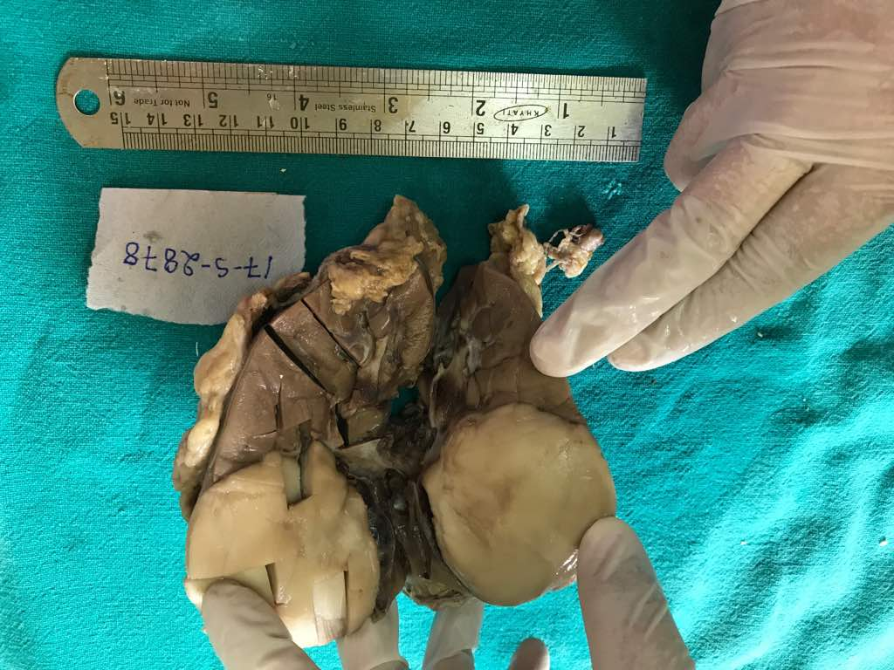
Figure 1 a well circumscribed growth on the upper pole.

On microscopic examination, a well circumscribed tumor with small, uniform, closely packed tubules accompanied by scant stroma. Cells were cuboidal with minimal cytoplasm, bland nuclei and uniform chromatin.
Focal papillary architecture and glomeruloid bodies were also seen. Psammoma bodies were also seen . rest of the renal tissue appeared normal. All these features were suggestive of metanephric adenoma
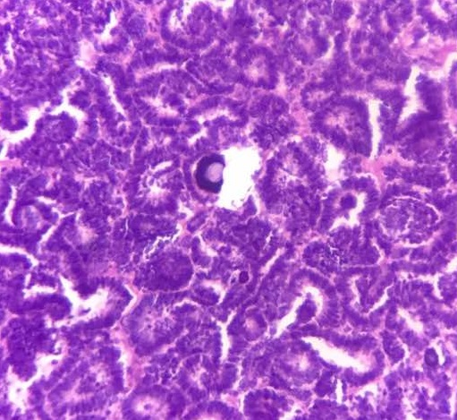 Figure 2. microscopy, metanephric adenoma with a Psammoma body in the centre.

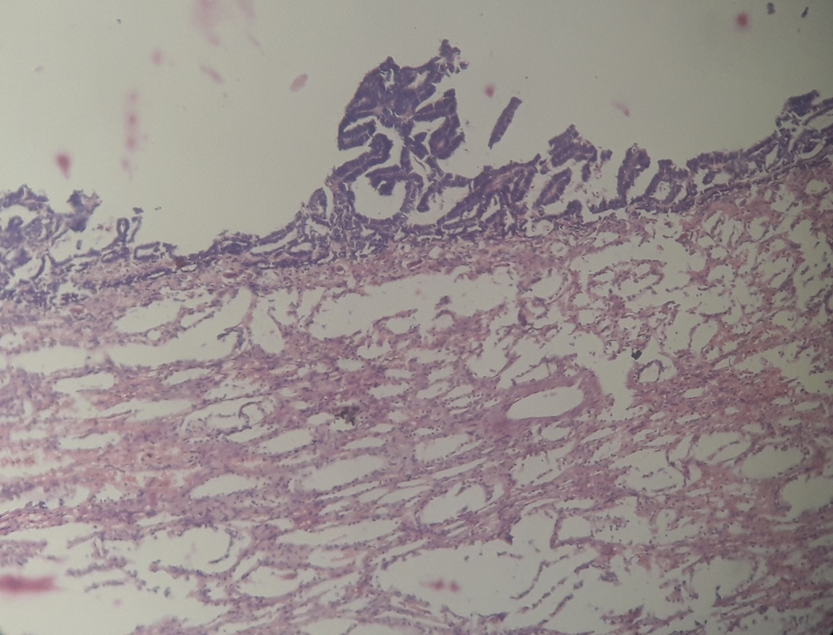

Figure 3. Focal papillary architecture
DISCUSSION:

Histologically, metanephric adenoma have either sparse fibrous capsule or no capsule at all¹.
Metanephric adenoma overlapse in morphology with epithelial-predominant nephroblastoma in children younger than 12 years and show morphology similar to papillary renal cell carcinoma in adults⁵.
Immunohistochemistry plays important role in diagnosis. Metanephric adenoma stains for CD57 and focally for CK7¹. Though it is benign, few cases of metastatic disease have been reported^{6,7}.
CONCLUSION:

ACKNOWLEDGEMENTS:

FUNDING:
COMPETING INTERESTS:

REFERENCE:

- Khoo CCK, Khetrapal P, Roux J, Bates AW, Mumtaz F (2014) Metanephric Adenoma: A case report with a Discussion of pathology and follow-up Duration. J Urol Res 1(3):1012.
- Jinous Saremian, MD, Melanie J Kubik, MD, Shahla Masood, MD.Cytologic features of metanephric adenoma of kidney : Case report and review of literature. Lab Med Spring 2015;46:153-158.
- Brisigotti M, Cozzutto C. Fabbretti G, Sergi C and Callea F: Metanephric adenoma Histol.
- Jingtao WU,Qingqiang ZHU, Wenrong ZHU and Hongying Zhang: Metanephric adenoma with diffuse calcifications: A Case report. Department of medical imaging, Subei people’s Hospital, Medical school of Yangzhou, Jiangsu 225001, P.R. china. Onchology letters 10: 1816-1818,2015
- Modern pathology(2015)28,1236-1248;doi:10.1038/modpathol.2015.81
- Pins MR, Jones EC, Martul EV, et al. Metanephric adenoma-like tumors of kidney:report of three malignancies with emphasis on discrimating features. Arch Pathol LabMed. 1999;123:415-420.
- Nakagawa T, Kanai Y, Fujimotott, et al. Malignant mixed epithelial and stromal tumors of the kidney:a report of the first two cases with a fatal clinical outcome. Histopathology.2004;44:302-4.

FIGURE WITH LEGENDS

TABLES:

