TITLE PAGE
{For instructions to fill this performa, please refer to the Author’s Guidelines}

Article Details:
Type of article | Case Report
Title | “An unusual case report: Hamartomatous nodule, sertoli cell adenoma in complete androgen insensitivity syndrome with Wolffian/Müllerian duct remnants”
Running Title | “An unusual case report: Hamartomatous nodule, sertoli cell adenoma in complete androgen insensitivity syndrome with Wolffian/Müllerian duct remnants.”

Authors’ Details
S. No. | Author/s Names (First Name, Middle Name and Surname) | email | Affiliation (Department and full name of institute)
1 | Dr Prashant Vijay Kumavat | drkumavat_83@rediffmail.com | LTMMC and LTMGH Sion, Mumbai
2 | Dr Chetan S Chaudhari | drchetanchaudhari26@yahoo.co.in | LTMMC and LTMGH Sion, Mumbai
3 | Dr Anita Padmanabhan | Drkumavat1947@gmail.com | LTMMC and LTMGH Sion, Mumbai
4 | Dr. Nitin M Gadgil | nmgadgil2412@yahoo.co.in | LTMMC and LTMGH Sion, Mumbai
5 | Dr Sangita S Margam | Drkumavat1947@gmail.com | LTMMC and LTMGH Sion, Mumbai
6 | Dr Ganesh R Kshirsagar | gkshirsagar31@yahoo.in | LTMMC and LTMGH Sion, Mumbai

[Add more names, if required]
Correspondence Details
Institution to which this study is associated with | LTMMC and LTMGH Sion, Mumbai
Corresponding Author’s Name, Mailing Address, e-mail address and phone number with country code and area code | Dr Prashant Vijay Kumavat, room no 1303, building no 27, hawre city, kasarvadvali, Thane (w) 400615
Other Details
Total Word Count | 1764
Total No of Tables | 00
Total No of Figures: | 03
Total No of References | 18
Funding Source | nil
Conflict of Interest (Y/N) | N
If Yes, Details
An unusual case report: Hamartomatous nodule, sertoli cell adenoma in complete androgen insensitivity syndrome with Wolffian/ Müllerian duct remnants
Abstract
Complete Androgen insensitivity syndrome is a disorder of hormone resistance characterized by a female phenotype with an XY karyotype and testes producing age-appropriate normal or higher concentrations of androgens. 26 year old unmarried phenotypically female presented with left inguinal swelling and never consulted for amenorrhea. MRI finding revealed bilateral inguinal masses, uterus cervix not visualized and hypoplatic vagina was noted. She had advised karyotyping which was 46 XY. Hormonal investigation showed testosterone, estradiol and LH was increase and FSH was within normal limits. Patient underwent laparoscopic bilateral gonadectomy with left open hernia repair. Histopathology examination revealed hamartomatous nodule, sertoli cell adenoma, leydig cell hyperplasia, which are more pronounced as age advances as result of absent activity of androgen. Fallopian tube, underdeveloped vas deference, Wolffian/ Müllerian cysts lined by cuboidal epithelium was also noted which may be reminiscent of Wolffian/ Müllerian structure. IHC revealed PLAP and CD 117 which were negative. The clinical, MRI, laboratory and histopathology findings confirmed diagnosis of complete androgen insensitivity syndrome.
Key words: Complete androgen insensitivity syndrome, Gonads, Hamartoma,
Müllerian, Wolffian.

Introduction: Complete androgen insensitivity syndrome (CAIS) is a female phenotype with a male karyotype (46, XY) which resulted from inactivating mutation in the androgen receptor (AR) gene. ^{[1]} The targeted response to testosterone or dihydrotestosterone is annulled due to mutation. As a result, male external genitalia differentiation and Wolffian duct development do not occur correctly. Sertoli cells of normally developed gonads produces anti-Mullerian hormone which regress Müllerian duct. Residual Müllerian structures exist approximately in one third of patients. ^{[2]} Development of the gonads is normal, and serum androgen level is comparable with that of a normal male. Most of the patients with complete androgen insensitivity typically presents either at puberty with primary amenorrhea or before puberty with masses in the inguinal canal that are subsequently identified as testes. Breast development occurs because of the aromatization of the excess testosterone into oestrogen and pubic hair tends to be sparse or absent. External genitalia are that of female with short vagina and absent uterus, cervix, or fallopian tubes. After development of secondary sexual character testes either in the inguinal canals or in the pelvis, should be removed because gonadal tumours are known to develop in 5 % of cases. ^{[3]} We report a case of complete androgen insensitivity syndrome in 26 unmarried female but found to have a 46, XY genotype, with hamartomatous nodule, sertoli cell adenoma and residual Müllerian/Wolffian tissue.

Case report: 26 year old unmarried female, presented to surgery OPD with left inguinal swelling which increases on straining and coughing since 4 years. She was amenorrheic but never consulted for this complained to physician. She had past history of right inguinal hernia operated four years back. MRI finding revealed bilateral inguinal masses, 2 x 1.1 cm inguinal mass anterior to external iliac vessel on right side, similarly 2x1 cm on left side anterior to external iliac vessel (Figure 1 A, B). Uterus cervix not visualized and small tubular structure was noted between urethral and anal opening suggestive of hypoplatic vagina. She had not attained menarche but attained thelarche (breast development) 12 years back. On local examination atrophic vagina and clitoris was present. She had absent axillary and pubic hair growth. She had advised karyotype which was 46 XY. Hormonal investigation showed, testosterone 251.4 ng/dl (increase), Follicle stimulating hormone (FSH) 9.88 mIU/ml (normal), Luteinizing hormone (LH) 82.84 mIU/ml (increase), estradiol 413 pg/ml (increase) and progesterone 0.19 ng /ml (decrease). On examination under anaesthesia ovaries, uterus were not present and bilateral small atrophied gonads were present. Widen left sided deep inguinal ring with left side gonads partially herniating was observed. Patient underwent laparoscopic bilateral gonadectomy with left open hernia repair.
Grossly we received left mass which measures 6x3x2 cm, cut section showed grey white nodule measuring 1.2x1cm and right sided mass measures 5X3X2 cm and cut section was grey white in appearance. (Figure 1C). Histopathology examination of both masses showed hamartomatous nodule of sertoli and leydig cells, which is well circumscribed and composed of sertoli cells tubules and leydig cell in between tubule and leydig cell hyperplasia (Figure 2 A). At many places fibrotic stroma with atrophic seminiferous tubule were noted (Inset Figure 2 A). Areas of ovarian like stroma were noted (Inset Figure 2B). Sertoli cell adenoma - Seminiferous tubules have little fruitless lumens and typically contain just sertoli cells were also noted (Figure 3 A, B). There was no evidence of spermatogenesis in any of the structures and no apparent malignant changes. Fallopian tube, underdeveloped vas deference, and Wolffian/ Müllerian duct cysts lined by cuboidal epithelium was also noted (Figure 3 C, D). IHC revealed PLAP and CD 117 which were negative (Figure 3 E, F). The clinical, MRI, laboratory and histopathology findings confirmed the diagnosis of complete androgen insensitivity syndrome

Discussion
Androgen insensitivity syndrome (AIS) is an X-linked male pseudo hermaphroditism also known as testicular feminization syndrome in which clinically patients phenotypically is female but shows 46 XY genotype. ^{[4]} The frequency of this syndrome was estimated about 0.05% (∼70/140000). ^{[5]} In post pubertal patients, the most frequent cause for consultation is primary amenorrhea; however, in prepubertal patients, AIS is often diagnosed during the investigation of inguinal hernia. ^{[6]} There are 2 types of ASI: complete and incomplete; the estimated prevalence of CAIS is about 1:20,000-64,000 male births. ^{[7]} In most of the cases CAIS, phenotypically female present with normal female external genitalia like a short blind ending vagina but there will be an absence of Wolffian duct derived structures like vas deferens and seminal vesicles epididymis and prostate. Although pubic and axillary hair are sparse or absent but breast development is recognised at puberty. ^{[7]}
The histologic pattern of testes removed from adult patients with AIS is similar to that of many cryptorchidic, infantile or immature testes. ^{[4, 8, 9]} Hamartoma and sertoli cell adenomas are frequent in the testes of AIS patients which is also seen in our case. ^{[8]} Although some differences regarding testicular histology between the complete and incomplete forms of AIS were reported in the first studies ^{[7]} later studies of a wide series of patients concluded that there are no histologic differences in the testicular pattern between the 2 forms. ^{[9]}
Rutgers and Scully reported 2 histopathological testicular patterns in AIS, namely, hamartomas (hamartomatous nodules) and sertoli cell adenomas. ^{[8]} Hamartomas consisted of solid tubules filled with immature sertoli cells, prominent leydig cells, and rare fascicles of smooth muscle. Multiple hamartomas occurred in 63% of AIS cases (bilateral in 40% of cases). Sertoli cell adenomas consisted of small tubules that were filled by immature sertoli cells and scant leydig cells and occurred in 23% of cases. In the present case, hamartomatous nodule were seen with sertoli cell adenoma and leydig cell hyperplasia. We think that the development of hamartomas in AIS is not neoplastic proliferation of sertoli cells but it results from malformative process of the congenitally hypoplastic seminiferous tubules.
Regression of the Müllerian structures occurs (the fallopian tubes, uterus, and upper portion of the vagina) because of AMH (Anti- Müllerian hormone) secreted by sertoli cells of the testis. The incomplete regression of Müllerian remnants can be due to 1) Deficiency of secretion of AMH, 2) AMH although secreted enough but it’s not functional, 3) Lack of response by the Müllerian tissue to AMH because of the high oestrogen levels caused by the conversion of testosterone to oestrogen in the androgen insensitive foetus, 4) Early testicular descent that removes the Müllerian structures out of the effective range of the AMH. ^{[10. 7, 11, 12]} There is a possibility of common link between androgen insensitivity syndrome and defective action of AMH, this can be suggested as there are persistence of the Müllerian remnants in patients diagnosed with complete androgen insensitivity syndrome. ^{[13]} In one of the studies from Netherlands (one of the largest databases compiled) of the families examined revealed 3 of 7 CAIS families had female siblings with differing Müllerian remnants. ^{[14]} 1/3 of the case showed fallopian tube which is also noted in our case. ^{[8]} One more interesting fact seen in our case is presence of underdeveloped vas deference that may be reminiscent of Wolffian duct. Wolffian/Müllerian duct cysts lined by cuboidal epithelium was also noted which may be reminiscent of that structure. Ovarian like stroma was present in our cases. ^{[15]} So this is very rare case showing finding of CAIS with discordant Wolffian/ Müllerian remnants, offering another example and more studies should be initiated and evaluated to study the cause leading to the residual tissue.
Some histopathological changes seen in our case that is Hamartomatous nodule, sertoli cell adenoma and leydig cell hyperplasia develop during puberty as a consequence of the almost or entirely absent activity of androgens in complete androgen insensitivity syndrome. ^{[15]} Decrease or absent germ cells, tubular atrophy, stromal atrophy occur early in childhood which may be due to abnormal location (inguinal) of the gonads. ^{[15]}
Intratubular germ cell neoplasia, can be diagnosed only if at least one cross section of seminiferous tubule contains a homogenous population of atypical germ cell with angulated nuclei. ^{[15]} This particular feature was absent in our case, which may be due to absolute loss of abnormal germ cells in adulthood when gonads would have been retained and a failure of progression of the pre-invasive lesions into an invasive cancer. In CAIS both these above mentioned mechanism may be due to lack of androgen action because of which there is risk of tumour development in patients with partial AIS as compared to CAIS (15% versus 0.8% in complete androgen insensitivity syndrome according to Cools et al). ^{[16]}
Due to alteration in androgen receptor gene which causes end organ resistance to the testosterone, leading to testosterone and LH levels are usually elevated in AIS. ^{[7]} In AIS excess of testosterone is converted to oestrogen in periphery which causes increase levels of estradiol, while FSH levels are normal. This suggest that regulation of FSH secretion is maintained by the combine action of estradiol and gonadal hormone like Inhibin. ^{[17, 18]}
In conclusion Hamartomatous nodule, sertoli cell adenoma, leydig cell hyperplasia are more pronounced as age advances as result of absent activity of androgen. Presence of Wolffian/Mullerian remnants offering another example and an opportunity to further study the cause leading to the residual tissue in our case. Lack of androgen theory would correlate with significantly higher risk for tumor development in patient with partial androgen insensitivity syndrome as compared to complete androgen insensitivity syndrome.

References
- Hughes I, Davies J, Bunch T, Pasterski V, Mastroyannopoulou K, MacDougall J. Androgen insensitivity syndrome. The Lancet. 2012;380(9851):1419-1428.
- Nichols J, Bieber E, Gell J. Case of sisters with complete androgen insensitivity syndrome and discordant Müllerian remnants. Fertility and Sterility. 2009;91(3):932.e15-932.e18.
- Chen C, Chen S, Wang T, Wang W, Hwu Y. A frame shift mutation in the DNA-binding domain of the androgen receptor gene associated with complete androgen insensitivity, persistent müllerian structures, and germ cell tumours in dysgenetic gonads. Fertility and Sterility. 1999;72(1):170-173.
- Morris J, Mahesh V. Further observations on the syndrome," testicular feminization". American journal of obstetrics and gynaecology. 1963 Nov 15;87:731.
- D Farhud D, Zarif Yeganeh M, Sadighi H, Zandvakili S. Testicular Feminization or Androgen Insensitivity Syndrome (AIS) in Iran: a Retrospective Analysis of 30-Year Data. Iranian Journal of Public Health. 2016;45(1):1-5.
- Bangsbøll S, Qvist I, Lebech P, Lewinsky M. Testicular feminization syndrome and associated gonadal tumours in Denmark. Acta Obstetricia et Gynecologica Scandinavica. 1992;71(1):63-66.
- Quigley C, Bellis A, Marschke K, El-Awady M, Wilson E, French F. Androgen Receptor Defects: Historical, Clinical, and Molecular Perspectives. Endocrine Reviews. 1995;16(3):271-321.
- Rutgers J, Scully R. The Androgen Insensitivity Syndrome (Testicular Feminization). International Journal of Gynaecological Pathology. 1991;10(2):126-144.
- Teter J, Boczkowski K. Testicular feminization with and without clitoral
enlargement. Am J Obstet Gynecol. 1966;94:813–819
- Dodge S, Finkelston M, Miyazawa K. Testicular feminization with incomplete
Müllerian regression. Fertility and Sterility. 1985;43(6):937-938.
- Heller D, Ranzini A, Futterweit W, Dottino P, Deligdisch L. Müllerian remnants in
complete androgen insensitivity syndrome. International journal of fertility. 1992;37(5):283.
- Ulloa-Aguirre A, Mendez J, Chavez B, Carranza-Lira S, Angeles A, Perez-Palacios G. Incomplete regression of Müllerian ducts in the androgen insensitivity syndrome. Fertility and Sterility. 1990;53(6):1024-1028.
- Damiani D, Mascolli M, Almeida M, Jaubert F, Fellous M, Dichtchekenian V et al. Persistence of Mullerian Remnants in Complete Androgen Insensitivity Syndrome. Journal of Paediatric Endocrinology and Metabolism. 2002;15(9):1553-1556.
- Boehmer A, Brüggenwirth H, Van Assendelft C, Otten B, Verleun-Mooijman M,
Niermeijer M et al. Genotype versus Phenotype in Families with Androgen Insensitivity Syndrome. The Journal of Clinical Endocrinology & Metabolism. 2001;86(9):4151-4160.
- Kaprova-Pleskacova J, Stoop H, Brüggenwirth H, Cools M, Wolffenbuttel KP, Drop SL, Snajderova M, Lebl J, Oosterhuis JW, Looijenga LH. Complete androgen insensitivity syndrome: factors influencing gonadal histology including germ cell pathology. Modern Pathology. 2014;27(5):721-30.
- Cools M, Drop S, Wolffenbuttel K, Oosterhuis J, Looijenga L. Germ Cell Tumours in the Intersex Gonad: Old Paths, New Directions, Moving Frontiers. Endocrine Reviews. 2006;27(5):468-484.
- Imai A, Ohno T, Nakagawa M, Sawairi M, Tamaya T. Incomplete testicular feminization syndrome: studies of 17 -oestradiol-binding activity and aromatase activity in cultured genital fibroblasts showing impaired dihydrotestosterone-binding. Annals of Clinical Biochemistry: An international journal of biochemistry and laboratory medicine. 1992;29(2):153-158.
- Schmitt S, Knorr D, Schwarz H, Kuhnle U. Gonadotropin regulation during puberty in complete androgen insensitivity syndrome with testicles in situ. Hormone Research. 1994;42(6):253-256.

Figure with Figure Legends
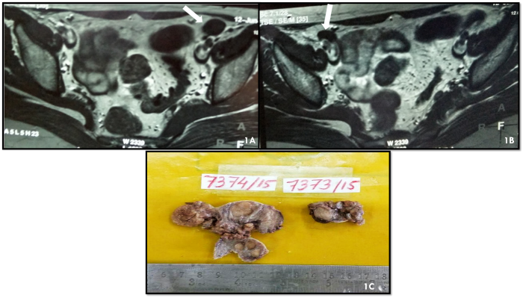

Figure 1: 1A MRI Scan - 2.3 x 1.1 cm inguinal mass anterior to external iliac vessel on right side. 1B MRI - 2x1 cm on left side anterior to external iliac vessel. 1C- Gross- Left mass measures 6x3x2 cm, cut sections showed grey white nodule measuring 1.2x1cm. Right sided mass measures 5X3X2 cm and cut section showed grey white

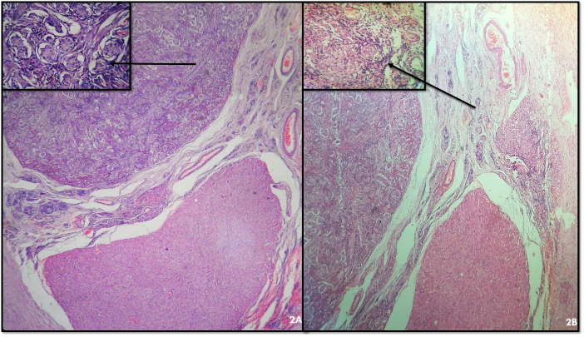
Figure 2: 2A- Well circumscribed Hamartomatous nodule of sertoli and leydig cells and leydig cell hyperplasia (H and E 100x) Inset - At many places fibrotic stroma with atrophic seminiferous tubule were noted. 2B- Inset- Areas of ovarian like stroma was noted.

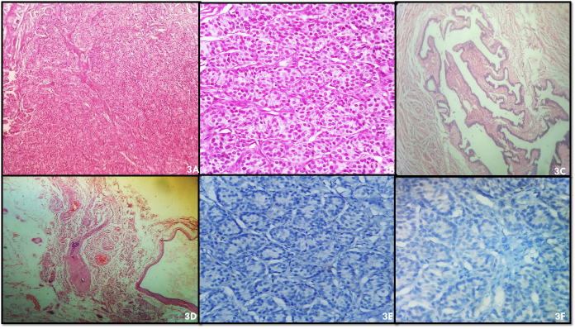
Figure 3: 3A- Sertoli cell adenoma - Seminiferous tubules have little fruitless lumens and just sertoli cells (H and E 100x). 3B- High power of 3A (H and E 400x). 3C- Fallopian tube like structure. 3D – underdeveloped vas deference and Wolffian/ Müllerian duct cysts lined by cuboidal epithelium. 3E- CD 117 negative. 3F- PLAP negative

