MANUSCRIPT
TITLE: RAPID CYTODIAGNOSIS BY DIFFERENT STAINING TECHNIQUES IN COMPARISON WITH CONVENTIONAL STAINS IN THYROID CYTOLOGY
ABSTRACT
BACKGROUND
Fine needle aspiration cytology (FNAC) is a very important component of pre-operative / pre-treatment investigation in combination with clinical, radiological and other laboratory data. In spite of its advances and advantages, conventional FNAC fails to achieve a 100% accuracy. To improve the accuracy of FNAC, a supravital stained Toluidine blue wet mount (TBWM) preparation of the aspirate and Methylene blue/Eosin (M/E) stained smears are studied which will give additional information regarding the lesion on which FNAC is done.
OBJECTIVE
To assess the diagnostic rapidity of the Toluidine blue wet mount preparation and Methylene blue/Eosin stain in FNAC and to compare the morphological features and results obtained from rapid stains with conventional PAP and H&E techniques in FNAC.
MATERIALS AND METHODS
The study was conducted on Fine needle aspirates from 100 patients presenting with thyroid swelling in R.L Jalappa hospital attached to Sri Devaraj Urs Medical College, Kolar, Karnataka. TBWM, M/E stain, H&E stain and Pap stain was done for all 100 cases. Time taken for each stain is assessed and the morphology of rapid stains were compared with the conventional stain. Quality index was calculated for all the stains.
RESULTS
The rapidity of the stains was assessed for all four stains. Toluidine blue wet mount takes only 2 minutes for staining followed by Methylene blue/eosin which takes 5 minutes. M/E stain gave the same result as compared to the conventional stains [PAP and H&E]. In TBWM there was difficulty in diagnosing few cases due to three dimensional clusters. The sensitivity and specificity of TBWM were 66% and 90% whereas for M/E stain 98% and 100%. The quality index of PAP stain, H&E stain, M/E stain and TBWM were 0.85, 0.81, 0.71, 0.66.
CONCLUSION
Thus, both stains can be routinely undertaken as a supplementary procedure for conventional stains to improve the cellularity and to reduce the time taken for re-sampling.
KEYWORDS: Toludine blue wet mount, Methylene/Eosin, Rapid cytodiagnosis, Quality index

MAIN TEXT

TITLE: RAPID CYTODIAGNOSIS BY DIFFERENT STAINING TECHNIQUES IN COMPARISON WITH CONVENTIONAL STAINS IN THYROID CYTOLOGY

INTRODUCTION
Fine needle aspiration cytology (FNAC) technique has become more common and popular nowadays. Though it is not a substitute for conventional histopathology, it should be regarded as a very important component of pre-operative / pre-treatment investigation in combination with clinical, radiological and other laboratory data.^{[1,2]} Since the majority of lumps are benign, FNAC plays a major role in making a diagnosis and planning appropriate management.^{[3,4]}
The diagnostic accuracy of FNAC depends on adequacy and representativeness of sample and good cytomorphological detail without much artifactual distortion. Conventional FNAC has its own advantages and limitations, which are well known to any cytopathologist. In spite of its advances and advantages, conventional FNAC fails to achieve a 100% accuracy. This is partly because of, (i) A lack of sufficient cellularity in desmoplastic lesions. (ii) Wastage of aspirated cells when they stick to the hub and lumen of the needles, (iii) Morphological distortion produced when the cells are trapped in fibrin mesh, (iv) Distortion of fragile cells during smearing, (v) Loss of cell to cell and cell to stromal architecture.^{[1,2]}
Hence in an attempt to improve its accuracy, a supravital stained Toluidine blue wet mount (TBWM) preparation of the aspirate and Methylene blue/Eosin (M/E) stained smears are studied which will give additional information regarding the lesion on which FNAC is done. These supravital stains attains good definition of cell outline, cytoplasmic contents and nuclear details.
Therefore this study is aimed at assessing the diagnostic rapidity of the Toluidine blue wet mount preparation and Methylene blue/Eosin stain in FNAC and to compare the morphological features and results obtained from rapid stains with conventional PAP and H&E techniques in FNAC.
MATERIALS AND METHODS
The study was conducted on Fine needle aspirates from 100 patients presenting with thyroid swelling in R.L Jalappa hospital attached to Sri Devaraj Urs Medical College, Kolar, Karnataka. Consent was taken from all the patients included in the study. Aspirates yielding very little material was excluded from the study.
STAINING PROCEDURE
TOLUDINE BLUE WET MOUNT STAINING
Step 1: A drop of fine needle aspirate is expressed on centre of slide
Step 2: In case of body cavity fluid cytology drop of fluid was placed in the center of slide if fluid was turbid or the fluid was centrifuged at 1500 rpm/min for 10 minutes. The supernatant fluid was discarded. Then a drop of well mixed sediment was placed in the center of slide.
Step 3: Add drop of 0.5% Toluidine blue stain
Step 4: Mix with needle
Step 5: Add a drop of diluted Eosin stain and mix well (optional)
Step 6: Cover with cover slip
Step 7: Wet mount was examined under microscope and cytomorphology was observed.
ALTERNATIVE METHOD OF PREPARATION OF WET MOUNT
This method was tried whenever aspirates were very scanty and adhered to hub of the needle. Under such condition it was very difficult to express the aspirate over the slides.
Step 1: A few drops of toluidine blue stain was aspirated using the same syringe and needle and rinsed.
Step 2: Then the stain mixed material was expressed in the center of slide.
Step 3: A drop of eosin solution was placed next to cell stain mixture and mixed well (optional)
Step 4: Cover with cover slip
Step 5: Wet mount was examined under microscope and cytomorphology was observed.

METHYLENE BLUE ALKALINE/EOSIN STAINING
Step 1: Air dry the smear
Step 2: Fix smear in 95% methanol – 1 min
Step 3: Wash in running tap water
Step 4: 1 Dip in 1% eosin
Step 5: Wash in running tap water
Step 6: 1 dip in Loffler’s methylene blue alkaline
Step 7: Wash in running tap water
Step 8: Air dry and mount with DPX
Toludine blue wet mount preparation, Methylene/Eosin stain, H&E stain and Pap stain was done for all 100 cases. Time taken for each stain is assessed and the morphology of rapid stains were compared with the conventional stain.
ASSESSMENT OF QUALITY INDEX
The morphology of the cells was assessed using the following scoring system for all the four stains on all 100 cases using the following scoring system. [Table 1]

The maximum score for a single case, taking into account of all the four parameters, was 11. Thus, the maximum possible score in the study was calculated by multiplying the number of cases by 11 for each of four stains. The “Quality index” was obtained by finding out the ratio of actual score obtained to the maximum score possible.
QUALITY INDEX = Actual score obtained / maximum score possible.^{[5]}
STATISTICAL ANALYSIS
We used the IBM SPSS Software (v.22) to perform the statistical analysis. Validation of rapid cytodiagnostic tests was done against the gold standard PAP and H&E stains using tests like Sensitivity, Specificity, Positive predictive value and ROC curve. The p value ≤ 0.05 was considered significant.
RESULTS
100 cases with good cellularity where all stains can be performed were chosen for the study. For each case four stains have been done and were analysed by two pathologists for the morphological features and for final diagnosis. Pathologists were blinded for final diagnosis.
RAPIDITY ASSESSMENT
The rapidity of the stains was assessed for all four stains. Toluidine blue wet mount takes only 2 minutes for staining followed by Methylene blue/eosin which takes 5 minutes. [Table 2]
Out of these 100 cases M/E stain gave the same result as compared to the conventional stains [PAP and H&E] except for 2 cases of Lymphocytic thyroiditis are diagnosed as Benign thyroid lesion. This is due to lymphocytes in these two cases were identified as naked follicular epithelial cells. In TBWM there was difficulty in identifying Hyperplastic goiter due to three dimensional clusters and difficulty in identifying Hurthle cells and fire flares. The next difficulty we faced is to diagnose Papillary carcinoma of thyroid as the nuclear grooves and inclusions are not well appreciated in TBWM. Thus the total number of concordant cases by TBWM is 73. [Table 3]
Discordant thyroid lesions by wet mount technique and M/E stain in comparison with conventional stains [PAP and H&E] are shown in Table 4 & 5. The sensitivity, specificity, positive predictive value and negative predictive value of TBWM and M/E stain were 66%, 90%, 70%, 100% and 98%, 100%, 98%, 100% respectively.[Table 6]
ROC Curve by comparing rapid stains with conventional stains are shown in figure 1. Area Under Curve for TBWM and M/E were statistically significant with p value <0.05. [Table: 7]
The morphology of the cells was assessed using the scoring system for all the four stains on all 100 cases and the quality index were calculated. [Table 8 & 9] The salient features of all four stains were shown in Table 10.
DISCUSSION
FNAC plays a vital role as a rapid diagnostic technique because of its simplicity, cost effectiveness, early availability of results, accuracy and minimal invasion. Chandler foot et al (1958), Silverman et al (1989) Verma et al (1991), Chang et al (1993), yang et al (1995), Tsou et al (1997) experimented various rapid stains such as Neutral red – Janus green, Diff Quik, rapid MGG, Liu’s stain, ultra-fast PAP, Riu’s stain respectively for immediate diagnosis.^{[6-11]} This work was inspired by the earlier work of Joy, M.P. et al in 2003 where they applied toluidine blue as a rapid stain for quick diagnosis of ultrasound guided aspiration cytology.^{[3]}
The rapidity of the stains was assessed and found that toluidine blue wet mount stains in 2 minutes followed by methylene blue/eosin in 5 minutes. Rapid staining technique has an advantage of assessing the cellularity and adequacy of the material within few minutes and the re-aspiration can be performed immediately. This will be of much help in USG or CT guided FNAC.
Caya et al in 1984 reported that false negative reports were resulted from unrepresentative aspirates. False negative aspirates may include normal or reactive elements but necrotic material is an additional source of error.^{[12,13]} This problem of sampling error cannot be eliminated entirely in FNAC but it is found reduced by rapid cytology assessment. This sampling error is reduced in our study by simultaneously doing rapid wet mount study.
Cagle et al., in 1993 reported that inadequate sampling was solely responsible for 10% false negative report in lung FNAC.^{[14]} In our study the needle and hub are rinsed with toluidine blue stain, which effectively washes all the cells collected in the lumen yielding an improved cellularity.
Degenerated cells and neoplastic cells are more fragile and distorted easily during smearing which created confusion in diagnosis. Trapping of cells within fibrin meshwork also distorted the morphology of cell. Since cytomorphology forms the basis for the cytodiagnosis, artifactual morphological distortion influences the diagnostic accuracy of FNAC.^{[7]}
This smearing artifact is avoided in our study since we used wet mount preparations as one of the rapid stain. The disadvantage of this wet mount technique was three dimensional clusters of cells which reduces the diagnostic accuracy in our study.
One of the most important features in cytodiagnosis is the morphology of the nucleus.^{[12]} The advantage of this supravital stain is that the cell structure is well preserved with toluidine blue stain.^{[15]} Supravital stain has a high affinity for DNA and hence absorbed rapidly into the nucleus. As the dysplastic and anaplastic cells contain more nucleic acid, the nuclear stains of tumor cells are very prominent with toluidine blue.^{[16]} Another advantage is the postfixation after air-drying facilitates chromatin staining in M/E stain which will improve the diagnostic accuracy in malignant cases.
Colloid stains blue to purple and form thin membrane like coat often with folds and cracks.^{[17]} In our study thick colloid stains as patchy dark blue colour material and thin colloid stains as granular purple material in both M/E and TBWM. The cyst macrophages are also well appreciated in both the stains. There was difficulty in identifying lymphocytic thyroiditis in M/E due to lymphocytes in two cases were identified as naked follicular epithelial cells [Fig 2]. The major discrepancy in TBWM was found in the cases of hyperplastic goitre, as the fire flares are not well appreciated. There was no difficulty faced in diagnosing hyperplastic goitre in M/E [Fig 3]. In cases of follicular neoplasm the arrangement of the cells in follicular pattern and the nuclear details was well appreciated in both M/E and TBWM. Anaplastic carcinoma of thyroid shows pleomorphic cells with prominent nucleoli and multinucleated cells which was well appreciated in both the rapid stains. Smear from papillary carcinoma of thyroid shows sheets of cell with enlarged ovoid nucleus, granular chromatin and prominent nucleoli with cytoplasmic inclusions and nuclear grooves. In our study papillary sheets of follicular cells showed nucleus with small prominent basophilic nucleoli and some with nuclear inclusion in M/E stain. But in TBWM the inclusions could not be identified [Fig 4].
The diagnostic accuracy of rapid stains were compared with other studies and shown in table 11.
The slides of TBWM could not be preserved since the cells were not fixed and should be photographed immediately. This is the major disadvantage of this stain. But it can be preserved for few hours, by sealing the cover slip by applying melted Vaseline or DPX. By this improvement the cytomorphology can be retained for a period of 2 to 3 hours without any morphological distortion and the quick drying of wet mount can also be prevented.
In most of the cases the material gets stuck in needle hub which is very difficult to obtain on the slide. This drawback was overcome by TBWM, where the toluidine blue is directly aspirated on the same needle used for FNAC and the material is expressed on the slide. This technique helps in obtaining the overall material from the needle and will improve the cellularity and helps in supplementing the conventional stains.
M/E stain helps in assessing the cellularity within few minutes which will guide us whether to proceed with the staining or to do re-aspiration. This method helps in reducing the time consumption in cases of USG guided FNAC and in intra operative cytodiagnosis.
CONCLUSION
Thus Toluidine blue wet mount and Methylene blue/Eosin stain can be used as a rapid diagnostic test. It is also used to assess adequacy of sample especially for deep seated lesions and in USG guided FNAC. It can be used for intra operative cytodiagnosis as an adjunct to frozen section diagnosis. Thus, both stains can be routinely undertaken as a supplementary procedure for conventional stains to improve the cellularity and to reduce the time taken for re-sampling. This work gives a new dimension to the art of FNAC and also opens a new door for further researches in this regard.

DECLARATION
Funding: None
Competing interest: None declared

REFERENCES
- Sumathi S, Mrinalini VR. Supravital stained wet film study of fine needle aspirates: A reliable supplementary diagnostic procedure. Clin Cancer Investig J 2012;1:135-39.
- Sumathy C, Durai SJ, Swaminathan K, Vallimanalan S, Munavarah SA. Supravital stained rapid wet mount preparation of fine needle aspirates-A cytomorphological study. tejms 2012;3:62-66.
- Joy MP, Iyer VK, Aron M, Kapila K, Verma K. Rapid staining using toluidine blue: A reliable method for quick diagnosis in ultrasound guided aspiration cytology. Indian J Pathol Microbiol 2003;46:589-92.
- Erkilic S, Kocer NE. Diagnostic accuracy of toluidine blue stained wet films in effusion cytology. Acta Cytol 2006;50:407-9.
- Idris AAA, Hussain MS. Comparison of the efficacy of three stains used for the detection of cytological changes in Sudanese females with breast lumps. Sudanese J Pub Health 2009;4:275-77.
- Foot CN, Nelson D, Quist H. Supravital staining of sediments of serous effusions, a simple technique for Rapid Cytological diagnosis. Cancer 1958;11:151-157.
- Silverman JF, Finley JL, O’Brien KF, Dabbs DJ, Park HK, Larkin EW, et al. Diagnostic accuracy and role of immediate interpretation of fine needle aspiration biopsy specimen from various sites. Acta Cytol 1989;33:791-796.
- Verma K, Tiwari MC, Agarwal J, Kapila K. Diagnostic accuracy of immediate interpretation of fine needle aspiration. Indian J Med Res 1991;94:197-199.
- Chang MC, Chan RD, Ho WL. Intra operative cytology, the use of Liu’s stain for immediate diagnosis. Zhonghua Yi Xue Za Zhi (Taipei) 1993;51:368-375.
- Yang GC, Alvaraz ll. Ultra fast papanicolaou stain. An alternative preparation for fine needle aspiration cytology. Acta Cytol 1995;39:55-60.
- Tsou MH, Lin HH, Ko JS. Riu’s Stain and the cytologic diagnosis of thyroid fine needle aspiration a single cancer center experience. Diagn Cytopathol 1997;16:543-547.
- Caya JG, Clower LJ, Wollenberg NJ, Tiev TM. Transthoracoc fine needle aspiration cytology, Analysis of 82 patients with detailed verification criteria and evaluation of false negative cases. Am J Clin Pathol 1984;82:100-103.
- Winning AJ, Seed MJ, Husain WA, Metaxas OAN. Interpretation of Negative results in fine needle aspiration of discrete pulmonary lesions. Thorax 1986;41:875-9.
- Cagle PT, Kovach M. Ramzy I. Causes of false results in transthoracic fine needle aspirates. Acta Cytol 1993;37:16-20.
- David J, Henry CK, Feider, Splittgerber GF. Toluidine blue dye as a breast localization marker. Am J Roentqenol 1989;153:261-263.
- Dudgeon LS, Patrick CV. A new method for the rapid microscopical diagnosis of tumors. Br J Surg 1927;15:250-261.
- Orell SR. Fine needle aspiration cytology. 5th ed. New Delhi: Elsevier; 2013.

FIGURE WITH LEGENDS
Figure 1: ROC curve by comparing M/E and TBWM with conventional stains [PAP and H&E]
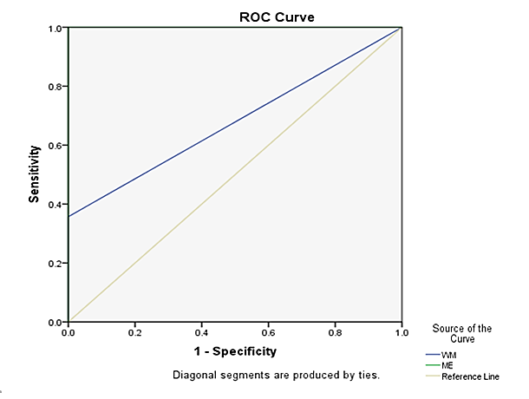
Figure 2: Lymphocytic thyroiditis: A – M/E, B – TBWM
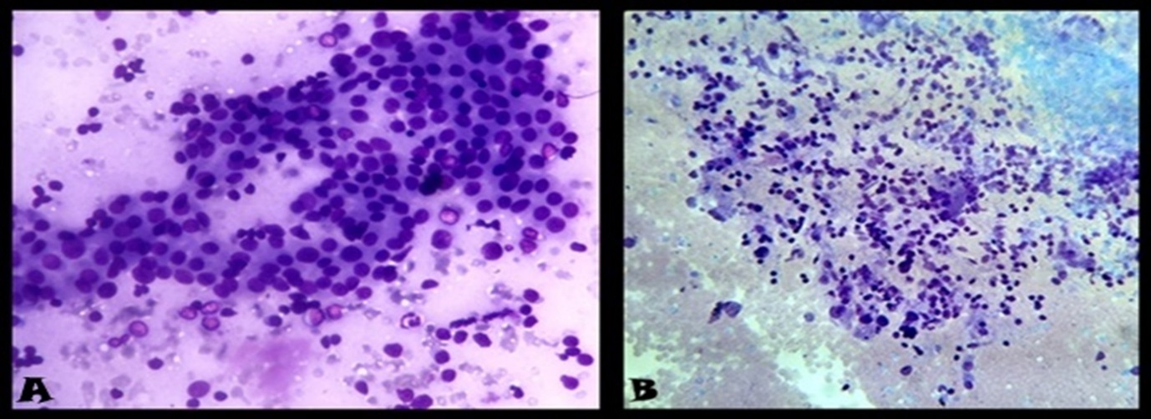

Figure 3: Hyperplastic goiter: A – M/E, B – TBWM
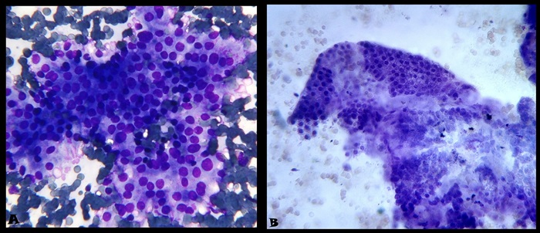

Figure 4: Papillary thyroid carcinoma: A – M/E, B - TBWM
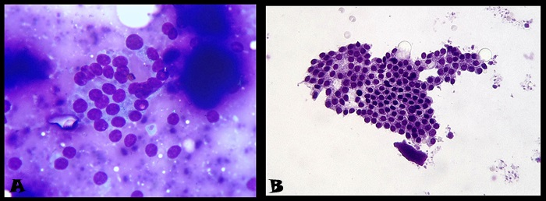

TABLES
Table 1: The scoring system to assess Quality Index.
SCORE | 1 | 2 | 3
SLIDE QUALITY  Background | Hemorrhage/Necrosis | Clean
Overall staining | Bad | Moderately good | Good
Cell morphology | Not preserved | Moderately preserved | Well preserved
Nuclear characteristics | Smudgy chromatin | Moderately crisp chromatin | Crisp chromatin

Table 2: Time taken for each staining technique
S. NO | STAINING TECHNIQUES | TIME TAKE FOR THE PROCEDURE
1 | Toluidine blue wet mount stain | 2 minutes
2 | Methylene blue/Eosin stain | 5 minutes
3 | H&E stain with artificial drying | 8 minutes
4 | PAP stain with artificial drying | 10 minutes

Table 3: Distribution of concordant thyroid lesions based on stains
NATURE OF LESION | CONVENTIONAL STAINS  (PAP AND H&E) | METHYLENE/EOSIN | WET MOUNT
Lymphocytic thyroiditis | 34 | 32 | 33
Colloid goiter | 19 | 19 | 19
Hyperplastic goitre | 17 | 17 | 4
Nodular goiter | 10 | 10 | 9
Benign thyroid lesion | 1 | 1 | 1
de-Quervains thyroiditis | 3 | 3 | -
Acute suppurative thyroiditis | 2 | 2 | 2
Suspicious for malignancy | 1 | 1 | -
Malignancy  Papillary carcinoma thyroid  Follicular neoplasm  Anaplastic carcinoma | 7  4  2 | 7  4  2 | -  3  2
TOTAL | 100 | 98 | 73

Table 4: Discordant thyroid lesions by wet mount technique in comparison with conventional stains [PAP and H&E]
DISCORDANT LESION NUMBER (n=27) | DIAGNOSIS IN CONVENTIONAL STAINS  [PAP and H&E] | DIAGNOSIS IN  WET MOUNT
4 | Hyperplastic goitre | Benign thyroid lesion
3 | Hyperplastic goitre | Lymphocytic thyroiditis
5 | Hyperplastic goitre | Nodular goitre
1 | Hyperplastic goitre | Colloid goitre
3 | de-Quervains thyroidtis | Benign thyroid lesion
1 | Nodular goitre | Lymphocytic thyroiditis
1 | Lymphocytic thyroiditis | Nodular goitre
1 | Suspicious for malignancy | No opinion
7 | Papillary thyroid carcinoma | Benign thyroid lesion
1 | Follicular neoplasm | Hyperplastic goiter

Table 5: Discordant thyroid lesions by methylene blue/eosin technique in comparison with conventional stains [PAP and H&E]
DISCORDANT LESION NUMBER (n=2) | DIAGNOSIS IN CONVENTIONAL STAINS  [PAP and H&E] | DIAGNOSIS IN  METHYLENE BLUE/EOSIN
1 | Lymphocytic thyroiditis | Benign thyroid lesion
1 | Lymphocytic thyroiditis | Benign thyroid lesion

Table 6: Statistical analysis by comparing wet mount with conventional stains in thyroid lesions
STATISTICAL PARAMETERS | WET MOUNT | CONFIDENCE INTERVAL | METHYLENE BLUE/EOSIN | CONFIDENCE INTERVAL
Sensitivity | 66 % | 46 – 100 % | 98 % | 73 – 100 %
Specificity | 90 % | 82 – 95 % | 100 % | 94 – 100 %
Positive predictive value | 70 % | 42 – 90 % | 98 % | 73 – 100 %
Negative predictive value | 100 % | 94 – 100 % | 100 % | 94 – 100 %

Table 7: Area Under Curve
Test Result Variable(s) | Area | Std. Errorª | p value^{b} | Asymptotic 95% Confidence Interval
 |  |  |  | Lower bound | Upper bound
WM | 0.679 | 0.092 | <0.033* | 0.499 | 0.858
M/E | 1.000 | 0.000 | <.0001* | 1.000 | 1.000
The test result variable(s): WM has at least one tie between the positive actual state group and the negative actual state group. Statistics may be biased.
a. Under the nonparametric assumption
b. Null hypothesis: true area = 0.5

Table 8: The results of estimating the efficacy of four stains (n=100)
PARAMETER | PAP  (n=100) | H&E  (n=100) | M/E  (n=100) | WETMOUNT  (n=100)
BACKGROUND
Hemorrhage/necrosis | 10 | 10 | 11 | 12
Clean | 90 | 90 | 89 | 88
OVERALL STAINING
Bad | 11 | 15 | 21 | 39
Moderately good | 18 | 28 | 61 | 52
Good | 71 | 57 | 18 | 9
CELL MORPHOLOGY
Not preserved | 6 | 6 | 11 | 15
Moderately preserved | 32 | 38 | 63 | 72
Well preserved and crisp | 62 | 56 | 26 | 13
NUCLEAR CHARACTERISTICS
Smudgy chromatin | 15 | 16 | 28 | 34
Moderately crisp chromatin | 37 | 51 | 56 | 57
Crisp chromatin | 48 | 33 | 16 | 9

Table 9: Overall scores obtained by all four stains with Quality Index
PARAMETER | PAP | H&E | METHYLENE BLUE/EOSIN | WETMOUNT
Background score | 190 | 190 | 189 | 188
Overall staining score | 260 | 242 | 197 | 170
Cell morphology score | 256 | 250 | 215 | 198
Nuclear characteristics score | 233 | 217 | 188 | 175
Actual score obtained | 939 | 899 | 789 | 731
Maximum score possible | 1100 | 1100 | 1100 | 1100
QUALITY INDEX | 0.85 | 0.81 | 0.71 | 0.66

Table 10: The salient features of all four stains
Feeatures | pap | H&E | m/e | tbwm
Smearing technique | Important | Important | Important | Nil
Fixation | Immediate fixation | Immediate fixation | Air drying followed by fixation | Nil
Artifacts | Delay in fixation | Delay in fixation | Nil | Air bubbles
Cell loss | Due to wet fixation | Due to wet fixation | Minimal | Minimal
Cell size | Decreased, due to immediate fixation | Decreased, due to immediate fixation | Increased due to air drying | Increased
Cytoplasm | Well appreciated | Well appreciated | Moderately appreciated | Poor
Nucleus | Excellent | Excellent | Excellent | Moderately good
Nucleolus | Distinct | Excellent | Excellent | Excellent, appears immediately
Tissue fragment | Good | Good | Moderate | Moderate
Advantage | Crisp Nuclear details | Very good nuclear details, similar to PAP | Immediate assessment, Good nuclear details | Obtain material from needle hub
Disadvantage | Cell loss due to wet fixation | Cell loss due to wet fixation | Increased nuclear size due to drying | Three dimensional clusters masking the cellular details
Slide preservation | Preserved | Preserved | Preserved | Cannot be preserved
Cost | Expensive | Expensive | Cost effective | Cost effective
Rapidity | 10 minutes | 8 minutes | 5 minutes | 2 minutes

Table 11: Comparison of diagnostic accuracy of rapid stain with other studies
AUTHORS | YEAR OF THE STUDY | RAPID STAIN USED | DIAGNOSTIC ACCURACY
Chandler foot et al.⁶ | 1958 | Neutral red Janus green stain | 80%
Silverman et al.⁷ | 1989 | Diff-quik stain | 96%
Kusum verma et al.⁸ | 1991 | Rapid MGG stain | 97%
Chang et al.⁹ | 1993 | Liu’s stain | 94.9%
Tsou et al.¹¹ | 1997 | Riu’s stain | 93.5%
Joy MP et al.³ | 2003 | Toludine blue stain | 98.54%
Sumathy C et al.² | 2012 | Toludine blue wet mount | 89%
Sumathi S et all.¹ | 2013 | Toludine blue wet mount | 87%
Present study | 2015 | Toludine blue wet mount | 76%
Present study | 2015 | Methylene blue/eosin | 98%

