MANUSCRIPT (MAIN FILE)
TITLE: CLINICOPATHOLOGICAL STUDY OF MEDULLARY BREAST CARCINOMA – AN INSTUTUTIONAL STUDY

ABSTRACT
Background:
Medullary breast carcinoma (MBC) is a rare distinct type of invasive breast ca with incidence being less than 5%. Usually occurs under the age of 50 yrs, often mistaken clinically for fibroadenoma . They are divided into typical, atypical MBC with a prerequisite of syncytial growth pattern in more than 75% of the tumor cells. MBCs are often hormone (ER, PR, Her2/neu) negative with grade 3 Nottingham’s criteria but has better prognosis.

Methods: Retrospective study of invasive carcinoma of the breast was undertaken in pathology department from 2009-2016. Total number of invasive breast carcinoma were 388, of which MBC were 12 cases histologically.Clinical details, gross features were noted. HPE and IHC (ER, PR, Her2/neu) slides were reviewed.

Result: Age range was 35 – 64 yrs, with a mean of 49.08 years. All presented clinically as solitary lump in breast. No side predilection. Most common site affected was upper inner quadrant consitituing around 50%(6 out of 12) of cases. Overall tumour size ranged from 2.5 to 6 cms with a mean of 3.6 cms in typical and 4.25 cms in atypical MBC. Grossly majority of the tumors were soft to firm in consistency. Histologically 10 out of 12 cases ( 83.3%) were typical MBC and 2 cases were atypical MBC (16.7%) . IHC showed triple negativity in 75% of MBC with majority in typical MBC (80 %)
Conclusion: MBC is unique type of breast carcinoma with good prognosis. Histopathology plays important role in diagnosing variants of MBC since the treatment differs.
KEYWORDS: Medullary, breast carcinoma, typical, atypical, histopathology, IHC
MAIN TEXT

INTRODUCTION: Medullary breast carcinoma (MBC) is a rare, distinct type of invasive breast carcinoma ¹ with incidence of less than 5% of invasive breast carcinoma.^{1,2} Usually occurs under age of 50 years, often mistaken clinically for fibroadenoma.³ MBC are divided into typical and atypical medullary carcinomas , with a prerequisite of syncytial growth pattern in >75% of the tumor cells in both. Syncytial growth pattern is characterized by tumor cells arranged in sheets, usually more than four or five cells thick, separated by small amounts of loose connective tissue.⁴ Typical MBC is characterised by a constellation of five histological features, as defined first by Ridolfi et al in 1977.² These carcinomas are often hormone (ER, PR, Her2/neu) negative with grade 3 Nottinghams criteria ,basal phenotype ;but have a better prognosis.² Strong association of marked inflammation with better prognosis is seen in triple negative carcinomas.⁵ Presence of lymphocytes and plasma cells enables to keep in check MBC, prevents growth and spread quickly.¹ Over all five year survival rates is 95% in typical, 80% in atypical medullary carcinoma and 70% in invasive breast carcinoma^{6.}.In this background the study was undertaken to evaluate the prevalence of MBC and to study the clinicopathological and immunohistochemical profile in typical and atypical MBC.
MATERIALS AND METHODS:
Retrospective study of invasive carcinoma of the breast was undertaken in the department of pathology from 2009-2016. Total number of invasive breast carcinomas were 388, of which 12 cases were medullary carcinoma on histomorphology. All the 12 cases of MBCs were taken up for the study. The clinical data such as age of patient, nature of surgery etc were collected from the medical records. Gross features of specimen and appearance on cut surface were noted. Histopathology and IHC ( ER, PR, Her2/neu) slides were retrieved. Blocks were collected when slides were not available, subsequently sections were made and histopathology slides evaluated. Primary histologic feature defining both typical and atypical MBC, is presence of more than 75% syncytial tumour growth pattern and lymphoplasmacytic infiltrate in varying proportions.
Histological features characterising typical medullary carcinoma is the constellation of five histolological features such as more than 75% syncytial growth pattern, complete lesional circumscription, moderate to marked diffuse lymphoplasmacytic infiltrate, moderate to severe nuclear pleomorphism and lack of intraductal component and tubular differentiation.⁴
Atypical medullary carcinoma is defined histologically by not more than two of the following four atypical features such as margins with focal or prominent infiltrative pattern, mononuclear infiltrate mild or at the tumor margins only, benign appearing nuclei and presence of microglandular features.⁴
Immunohistochemical stained slides of ER, PR, Her2/neu were reviewed and analysed. Interpretation of ER, PR was done depending on the extent and intensity of nuclear staining as per Allred score. Interpretation of Her2/neu was done based on intensity of membrane staining pattern.
Data was analysed and evaluated using descriptive statistics such as median, range and and standard deviation.
RESULT
During the study period a total of 388 cases of invasive breast carcinoma were diagnosed out of which MBC cases were 12 , constituting about 3.1% of cases. Age range was 35-64 yrs, with a mean of 49.08 years. Age distribution of the cases shown in table 1. All cases clinically presented as solitary lump in breast. There was no side predilection however the most common quadrant affected was upper inner quadrant consitituing around 50% (6 out of 12) of cases. Modified radical mastectomy (MRM) was performed in all cases since FNA was reported as carcinoma breast.
Clinical features of typical and atypical medullary carcinomas are summarised in table 2 . Over all tumour size ranged from 2.5 to 6 cms with mean of 3.70 cms. Average size in typical MBC is 3.6 cms (range 2.5 to 6 cms ) and atypical MBC is 4.25 cms (range 3.5-5.0 cms). One of the twelve cases clinically presented with involvement of nipple areola region.
Grossly majority of the tumors were soft to firm in consistency. Fine needle aspiration cytology shows large, pleomorphic, singly scattered and disintegrated tumor cells with dense lymphoplasmacytic infiltrate in the background.
Histologically 10 out of 12 cases (83.3%) were diagnosed as typical MBC and 2 cases were atypical MBC (16.7%). Histological features of typical and atypical MBCs are summarised in table 3 and 4 . In our study, 40% of typical and 50% of atypical MBC showed metastatic deposits in the axillary lymph nodes.
IHC showed triple negativity in 75% cases of MBC comprising of 80 % in typical and 50% in atypical MBC
DISCUSSION:
MBC was first described by Moore and Foote in 1949.⁷ These are well circumscribed lesions ,often soft, fleshy and tend to bulge above the surrounding parenchyma, hence the term encephaloid.⁸ Medullary carcinoma is an uncommon tumor accounting for less than 5% of all invasive breast carcinomas. Prevalence of MBC in our study is 3.1% which is in concordance with various studies available in literature .^{1,2} Radiologically and clinically MBC mimics fibroadenoma due to its smaller size. Median size of the tumor ranged from 2-3 cms.³ Clinically they present as circumscribed tumor with tendency for cystic degeneration and ulceration of the skin in few. In present study 1 out of 12 cases showed ulceration of the skin involving the nipple areola region. According to the study conducted by Ridolfi et al⁹ ,age of presentation ranged from 47-52 years. Our study is concordant with the study done by Ridolfi et al and showed a mean age of 49.08 years. 60 % of typical MBC occurred in age group of 40-49 years, while 50 % of atypical MBC occurred in age group of 50-59 and 60-69 years (Table 1)
Grossly, medullary carcinomas are circumscribed, nodular, fleshy with grey pink appearance on cut surface(Fig 1A). Cystic degeneration, hemorrhage and necrosis are seen. Histologically, MBC is characterised by syncytial growth pattern (Fig 1B), complete circumscription (Fig 1C), moderate to marked diffuse lymphoplasmacytic infiltrate(Fig 1C), moderate to severe nuclear pleomorphism (Fig 1D ) and absence of glandular pattern. Presence of microglandular pattern , infiltrative margins, mild mononuclear infiltrate and benign appearing nuclei characterises atypical MBC⁴. Atypical MBC is synonymously named by some authors as invasive carcinoma with medullary with features.¹⁰
Wargotz ES et al reported 5 yr survival rate of 95%, 80% and 70% in typical , atypical MBC and invasive breast carcinomas respectively. In our study atypical MBC distinctly had IDC like areas with glandular formation of tumour cells and infiltrative tumour margins (Fig 2 F , G). Atypical MBC were 16.7% similar to study conducted by Jagtap et al.¹ Histopathological categorisation of atypical MBC is necessary since adujuvant chemotherapy is given along with MRM , unlike in typical medullary carcinoma where MRM is the mainstay of treatment¹⁰.The average number of lymph nodes found grossly in axillary dissection specimen from a patient with MBC is greater than for the other types of carcinoma. This difference is due to the greater ease of finding enlarged hyperplastic reactive lymph nodes in MBC .¹¹ Most studies indicate that the incidence of axillary lymph node metastases is lower in patients with medullary carcinomas (19%- 46%) than in those with atypical medullary carcinomas (30%-52%) or invasive ductal carcinomas (29%-65%).¹² In our study, the number of positive metastatic lymph node involvement were more in atypical MBC( 50%) compared to typical MBC. Typically MBCs are almost invariably triple hormone receptor negative, although some typical and atypical MBCs are ER, PR and/or HER-2 positive, indicating the heterogeneity of this type of breast carcinomas.¹³ In our study IHC showed triple negativity in 75% cases of MBC (Fig 3) with majority of in typical MBC (80%) similar to study conducted by Jagtap et al¹ .Of the two cases of atypical MBC, one case was ER ,PR positive ,while Her 2/neu negativity was noted in 100 %.
The treatment for MBC whether typical or atypical is similar to invasive ductal carcinoma. The division into typical and atypical subtypes has prognostic significance.¹⁴ Hence studies necessitates the categorization of MBCs since adujuvant chemotherapy is given along with MRM in atypical MBC, unlike in typical MBC where MRM is the mainstay of treatment.¹⁰
CONCLUSION:
MBC is the unique type of breast carcinoma with good prognosis. Larger studies are essential to understand the tumour biology in MBC. Atypical MBC have histological features of IDC as well. Histopathology plays a important role in diagnosing variants of MBC since the treatment differs.
ACKNOWLEDGEMENTS: nil

FUNDING: nil
COMPETING INTERESTS: nil

REFERENCE:

1. Jagtap VS, Beniwal A, Shah HP et al. Medullary carcinoma of breast : Clinicopathological study. J evid based med health 2016; 3(45):2256-60.
2. Chu Z, Lin H, Liang X, Huang R, Zhan Q, Jiang J et al. Clinicopathological characteristics of Typical medullary breast carcinoma: A retrospective study of 117 cases.PLoS ONE 2014;9(11): E111493.
3. Juan Rosai, Breast In Rosai and Ackerman's surgical pathology. 10th edition, Elsiever,Mosby,2011:1660-1773.
4.Tavasolli FA, Devilee P. World health organization classification of tumors,Pathology and genetics of tumors of breast and female genital organs. Lyon: IARC press;2003.
5. Marginean F, Rakha AE, Ho BC, Ellis IO,Lee AH. Histological features of medullary carcinoma and prognosis in triple negative basal like carcinomas of the breast. Modern pathology 2010;23:1357-63.
6. Sloane JP. Biopsy pathology of the breast. 2nd edition. New York : Oxford University Press;2001.
7.Moore OS, Foote FW. The relatively favourable prognosis of medullary carcinoma of the breast. Cancer 1949;2(4):635-64.
8. Chetty R.Gastrointestinal cancers accompanied by a dense lymphoid component: an overview with special reference to gastric and colonic medullary and lymphoepithelioma-like carcinomas. Clin Pathol 2012;65:1062–1065.
9. Ridolfi RL, Rosen PP, Port A, et al. Medullary carcinoma of the breast: a clinicopathological study with 10 year follow-up. Cancer 1977;40(4):1365-1385.
10.Kleer CG. Carcinoma of the breast with medullary-like features Diagnostic challenges and relationship with BRCA1 and ERH2 functions. Arch Pathol Lab med 2009;133:1822-1825.
11. Rosen PP, Lesser ML, Kinne DW, et al. Discontinuous or “skip” metastases in breast carcinoma. Ann Surg 1983;197:276–283
12. Dabbs DJ,Specail types of invasive breast carcinoma.In Breast pathology.2nd edition,Elseiver,Philadelphia,2017:639-662.
13. Santosh T, Bal AK, Patro MK, Choudhury A. Medullary Breast Carcinoma: A Case Report and Review of Literature. J Cancer Sci Ther 2015;7: 142-144.

14. Rosen PP.Medullary Carcinoma. In Rosen™ Breast Pathology. 3rd edition, Lippincott Williams & Wilkins, Philadelphia, 2009: 449-466.

FIGURE WITH LEGENDS
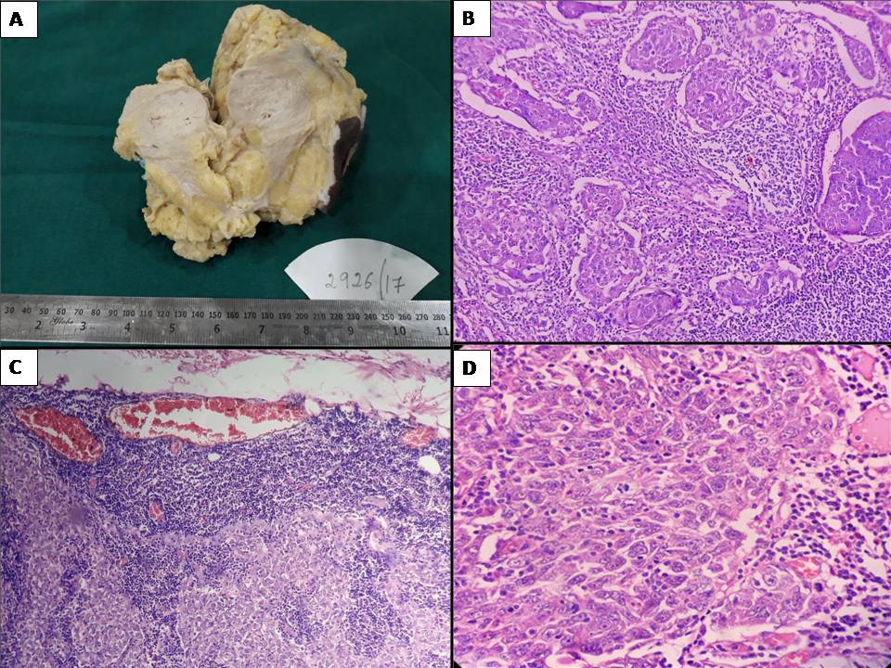
Figure 1
Typical MBC : A - GROSS showing well circumscribed , nodular fleshy grayish pink lesion
B - Syncytial growth pattern of tumor cells (H&E 10x)
C- Circumscribed tumor with moderate to marked lymphoplasmacytic infiltrate(H&E 4x)
D –Cells exhibiting high grade nuclear features (H&E 40 x)

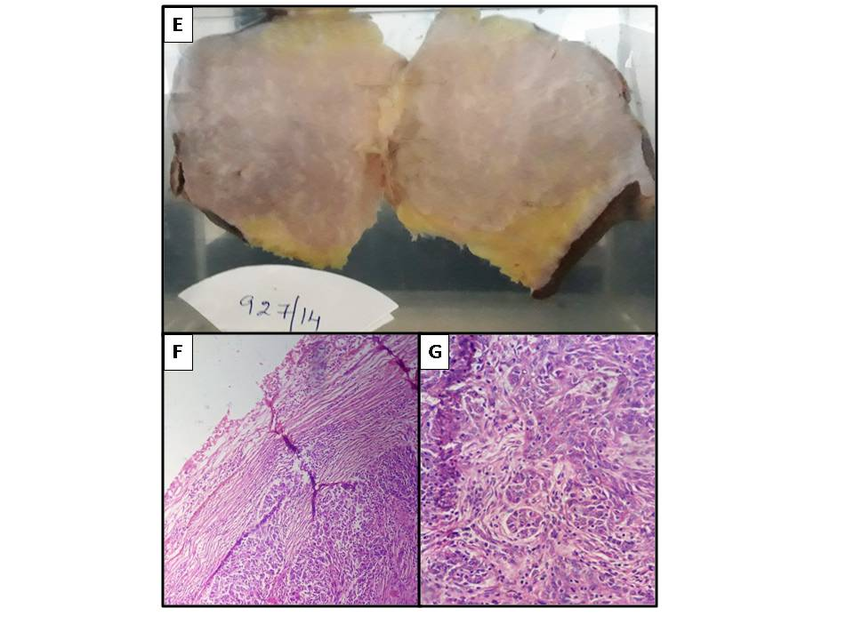
Figure 2 :ATYPICAL MBC:
E - Gross showing Large fleshy grey pink with infiltrative margins.
F – Tumor exhibiting infiltrative margins (H&E 10x)
G – High power showing glandular pattern (H&E 40x)

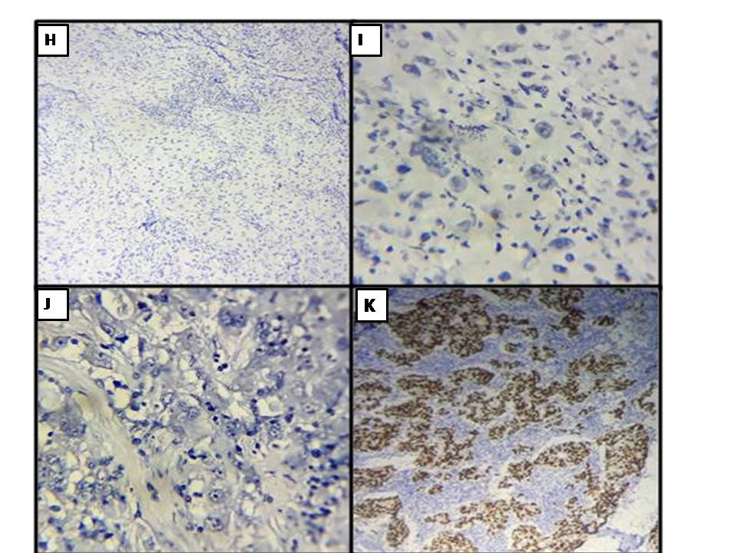
Figure 3 : Immunohistochemistry showing triple negativity ( ER,PR,Her2neu negative ) in fig H,I,J respectively and fig K showing ER positivity in one of the typical MBC.
TABLES:
TABLE 1 : AGE DISTRIBUTION OF TYPICAL AND ATYPICAL MEDULLARY CARCINOMA
AGE | Typical MBC | Atypical MBC
30-39 Yrs | 1 | 0
40-49 Yrs | 6 | 0
50-59 Yrs | 2 | 1
60-69 Yrs | 1 | 1

Table 2 : CLINICAL AND GROSS FEATURES OF TYPICAL AND ATYPICALR MEDULLARY CARCINOMA

 | AGE | Type of  Surgery | SIDE  QUAD | SIZE | Nipple/  Areola
Case 1  Typical MBC | 35 | MRM | Right  UOQ | 3X2.4X2 | 2.5-4
Case 2  Typical MBC | 58 | MRM | Right  UIQ | 3X2X2 | No
Case-3  Typical MBC | 64 | MRM | Right central Q | 4x3x2 | Ulcer-areola,cystic foci
Case 4  Typical MBC | 47 | MRM | Left  LOQ | 3X2.5x2 | No
Case 5  Typical MBC | 40 | MRM | Left  LOQ | 6x5x3 | No
Case 6  Typical MBC | 45 | MRM | Right UIQ | 4x3x3 | No
Case 7  Typical MBC | 42 | MRM | Left  UIQ | 4X3x2.5 | No
Case 8  Typical MBC | 45 | BX | Left  UIQ | 3x2x2.6 | No
Case 9  Typical MBC | 45 | MRM | Right  UOQ | 3.5X2.5X2 | No
Case 10  Typical MBC | 50 | MRM | Right  UIQ | 2.5X2.1X2 | No
Case 11  Atypical MBC | 60 | MRM | Left  UIQ | 5X4x3 | No
Case 12  Atypical MBC | 58 | MRM | Left  UOQ | 3.5X3X3 | No

Table 3 : HISTOPATHOLOGICAL FEATURES OF TYPICAL MEDULLARY CARCINOMA
 | Case 1 | Case 2 | Case3 | Case4 | Case 5 | Case 6 | Case 7 | Case 8 | Case 9 | Case 10
>75%  Syncy | + | + | + | + | + | + | + | + | + | +
Lp infiltrate | marked | marked | Marked | mod | mod | marked | mod | marked | marked | mod
pleomorphism | mod | mod | Marked | mod | marked | marked | marked | marked | marked | mod
DCIS/IDC  +/-  Absence of gland and intraductal formation | - | - | - | - | - | - | - | - | - | -
Necrosis %  1-10%  >10% | nil | nil | 1-10% | nil | nil | nil | nil | nil | nil | nil
Tumor border | wc | wc | wc | Push | push | wc | wc | wc | wc | push
Lymph node | 0 | 1/6 | 0/16 | 0 | 0/7 | 0/3 | 1/6 | 1/4 | 0/6 | 2/8
SBR GARDE | II | II | III | II | III | III | III | III | III | II
Stage | IIa | IIb | IIIb | IIa | IIb | IIa | IIb | IIb | IIa | IIb
ER/PR/HER 2 neu | -/-/- | +/+/- | +/+/+ | -/-/- | -/-/- | -/-/- | -/-/- | -/-/- | -/-/- | -/-/-

TABLE 4 : HISTOPATHOLOGICAL FEATURES OF ATYPICAL MEDULLARY CARCINOMA

 | Case11 | Case 12
>75%  Syncy | + | +
Lp infiltrate | mild | mild
pleomorphism | marked | mod
DCIS/IDC  +/-  Absence of gland and intraductal formation | DCIS | DCIS  LVI
Necrosis %  1-10%  >10% | >10% | nil
Tumor border | infiltr | infiltr
Lymph node | 3/8 | 12/26
SBR GARDE | II | II
Stage | IIa | IIIc
ER/PR/HER 2 neu | -/-/- | +/+/-

