TITLE PAGE

Article Details:
Type of article | Original article
Manuscript Title | CLINICO HISTOPATHOLOGICAL CORRELATION STUDY OF LEPROSY
Running Title | CLINICO HISTOPATHOLOGICAL CORRELATION STUDY OF LEPROSY

Authors’ Details
S. No. | Author/s Names  (First Name, Middle Name and Surname) | Email | Affiliation (Department and full name of institute)
1 | Bharat Ankush Ghodke | dr_b_ghodke@yahoo.co.in | Department Of Pathology,  Grant Government Medical College and Sir JJ group of Hospitals, Mumbai
2 | Arvind G Valand | arvind_valand@yahoo.co.in | Department Of Pathology,  Grant Government Medical College and Sir JJ group of Hospitals, Mumbai
3 | Aradhana Bhubaneswar Deka | aradhana.deka@gmail.com | Department Of Pathology,  Grant Government Medical College and Sir JJ group of Hospitals, Mumbai
4 | Sushma Nagsen Ramraje | sushmaramraje@gmail.com | Department Of Pathology,  Grant Government Medical College and Sir JJ group of Hospitals, Mumbai
5 | Zeba Shamshad Ali | zebanaushi@gmail.com | Department Of Pathology,  Grant Government Medical College and Sir JJ group of Hospitals, Mumbai
6
[Add more names, if required]
Correspondence Details
Institution to which this study is associated with | Grant Government Medical College and Sir JJ Group of Hospitals
Corresponding Author’s Name, Mailing Address, e-mail address and phone number with country code and area code | Dr. Aradhana Deka  Room No-302, High Rise Building  GT Hospital  Mumbai.  Email- aradhana.deka@gmail.com  +918108120630

Other Details
Total Word Count | 2698 (without bibliography)
Total No of Tables | 4
Total No of Figures: | 4
Total No of References | 23
Funding Source | None
Conflict of Interest (Y/N) | N
If Yes, Details | -

MANUSCRIPT (MAIN FILE)
TITLE: CLINICO HISTOPATHOLOGICAL CORRELATION STUDY OF LEPROSY

ABSTRCT
Background: Aim of the study was to study the histomorphological changes in leprosy, the clinicopathological correlation of different types of leprosy lesions and cases of clinically diagnosed lepra reaction.

Methods: One hundred and twelve patients of clinically diagnosed leprosy were chosen. Skin biopsy was performed, fixed in 10% buffered formalin, processed, sectioned and stained with Hematoxylin and Eosin as well as Modified Fite Faraco stain.

Result: Of the one hundred and twelve patients enrolled in the study (age range from 7 to 70 years) 90 patients were males and 22 were females. All cases were classified according to the Ridley Jopling Scale. Correlation between clinical diagnosis and histopathological type of leprosy and lepra reactions was done.

Conclusion: Leprosy is more common in males than in females having a ratio of 4:1.The commonest histopathological subgroup was tuberculoid leprosy.

KEYWORDS:
Tuberculoid, histopathology, leprosy, granuloma
MAIN TEXT

INTRODUCTION:
Leprosy is a chronic infectious, communicable disease caused by mycobacterium leprae, the leprosy bacillus, also known as Hansen bacillus named after himself (Hansen), discovered in 1873. [1]
Leprosy is a major public health problem, which still has a social stigma and myths attached to it. [2] It has been correctly said that some diseases do not take away the life, but they just ruin it. This holds true for leprosy because of the social stigma and complications like deformities associated with it. Though effective and simpler treatments are available, it is still difficult to identify early cases.
Leprosy is a very ancient disease dating back many centuries. Possibly it originated in Africa and spread very early to India. References of leprosy are found in Indian, Chinese & Egyptian medical literature. Mention about Leprosy has been made in Manu smriti and was referred to as “Kushtha” in the ancient Vedic writings. [3]
The prevalence rate is 2-4 per thousand population. India accounts for 1/3 of the leprosy cases in the world. [4]
2,13,899 leprosy cases reported in 2014 globally. India is still the country contributing largest number of new leprosy cases which account for 2/3rd of the new leprosy cases detected annually. In India, a total of 1,27,000 new cases were detected during 2013-2014. Annual new case detection rate (ANCDR) was 9.98/100000 population which decreased from 10.79 in 2012-2013. 33 states and union territories have achieved the level of elimination, i.e PR less than 1 case per 10,000 population. However, some areas still have high endemicity rate.(PR more than 1 case per 10,000 population) . [5]
Early diagnosis of leprosy is important to reduce the morbidity. Ridley and Jopling in 1974 suggested a classification system which employed correlation of clinical & histopathological status. Similar attempt to judge the utility of this method in the present study was undertaken.

MATERIALS AND METHODS:
A prospective study of 112 cases was carried out from April 2001 to June 2003.Clinical Examination was thoroughly done. Type of lesions such as hypopigmented anesthetic patch / plaque / papule / nodule / infiltration was noted.
A representative lesion was chosen for the present study and skin biopsy[6] was performed on O.P.D. basis. Biopsy was fixed immediately on removal in 10% buffered formalin and processed routinely and stained by Hematoxylin & Eosin Stain and Modified Fite - Faraco Stain.

RESULT
An attempt has been made to correlate clinically suspected cases of leprosy with histopathological findings and classifying them according to Ridley and Jopling Scale. [7]
Amongst 112 clinically diagnosed cases, 48 cases (42.85%) were of Borderline Tuberculoid Leprosy followed by 18 cases (16.11%) of Borderline Lepromatous Leprosy and only 1 case of Type I Lepra Reaction (0.89%).
Histopathologically out of the 112 cases, Tuberculoid leprosy was diagnosed with highest number of 36 cases (32.14%), followed by 31 cases of Borderline Tuberculoid Leprosy(27.68%), 14 cases of (12.5)%, 11 cases of Indeterminate Leprosy Lepromatous Leprosy (9.82%), 8 cases of Borderline Leprosy (7.14%), 6 cases of Borderline Lepromatous Leprosy (5.36%), 3 cases of Histoid Leprosy (2.68%), 2 cases of Type II Reaction (1.75%) and 1 case of Type I Reaction (0.89%).
There were 90 (80.35%) male patients and 22 (19.65%) female patients.
Age group varied from 1st decade to 7th decade and the maximum number of cases found in between the age group of 11 to 40 years. The youngest patient was of 7 years old while the oldest was 70 years old.
Majority of Leprosy lesions were situated on forearm. The remaining lesions were scattered over the body.
Out of 16 clinically diagnosed Tuberculoid leprosy cases, histopathological diagnosis was confirmed with 13 cases (81.25%), while 2 cases turned out to be of Borderline Tuberculoid Leprosy and 1 case of Indeterminate Leprosy.
Out of 48 clinically diagnosed cases of Borderline Tuberculoid Leprosy only 22 cases (45.83%) showed histopathological agreement and of the remaining cases 13 cases were diagnosed to be TT, 3 cases as BB, 1 case of Borderline Lepromatous Leprosy, 8 Indeterminate cases and 1 case showed Type I Reaction.
Out of the 4 clinically diagnosed Borderline Leprosy cases only 1 case showed agreement (25%), other 2 cases turned out to be of TT and 1 case of Borderline Lepromatous Leprosy.
Out of 18 clinically diagnosed Borderline Lepromatous Leprosy cases, only 2 cases showed histopathological agreement (11.11%). 5 cases were diagnosed to be Tuberculoid Leprosy, 4 cases of Borderline Tuberculoid Leprosy, 2 cases of Borderline Leprosy, 4 cases of LL and only 1 case was diagnosed as Indeterminate type of leprosy.
8 cases were clinically diagnosed as Lepromatous leprosy, of which 6 cases were confirmed with histopathology (75%), 1 case was diagnosed as BTH and other case was of Histoid Leprosy
There were 11 clinically suspected leprosy cases (clinically not divided in any group). In histopathological diagnosis, 3 cases turned out to be TT, 1 of BTH, 2 of BB, 1 of BLH, 1 of LL and 3 cases were diagnosed as indeterminate.
Out of two clinically diagnosed Histoid Leprosy showed 100% agreement on histology.
Out of 2 clinically diagnosed indeterminate cases one case (50%) showed agreement and the other case turned out to be BTH.
Clinically One case of Type I Reaction showed 0% agreement which turned out to be a case of BLH.
Clinically 2 cases of Type II Reaction showed 100% agreement on histopathology.

DISCUSSION:
A total of 1723 biopsies were received in our department during April 2001 to June 2003, of which Skin biopsies were 1099. Out of these, 112 cases were diagnosed as Leprosy (6.53%).
Since[8] Leprosy has a wide spectrum of Clinical manifestation; hence a good classification is an effective means of understanding and communicating concepts regarding a difficult case.
Ashok S.K. et al (1995) [9] studied 27 clinically diagnosed cases of Leprosy, in which they found 1 case (3.7%) of TT, 20 cases (74.07%) of BTH, 1 case (3.7%) of BB, 2 cases (7.40%) of BLH and 1 case of (3.70%) of LL.
Surinder et al in 1993[10] in their study found of 60 clinically diagnosed Leprosy cases, 25 cases (41.66%) were of BTH, 28 cases (46.66%) were of BLH and 7 cases (11.68%) were of LL.
In the present study variation of age group was found between 7 years to 70 years. 89 cases (79.46%) were between age group of 11-50 years. In the study of Rao P.S.S. et al. [11], adults were found to be affected twice than children. Mathur et al[12] in 1978 found that majority of cases were in the age group of 21- 50 years. This emphasise that although Leprosy is borne at an early age, but because of relatively long incubation period the symptomatic cases appear at later age.
In the present study there were 90 males (80.35%) and 22 females (19.65%). Male to female ratio was 4:1. Mathur et al[12] in 1978 and showed male preponderance of cases (3:1)
Coming to the site of Involvement leprosy lesions almost occur all over body. In our study, upper extremities (palm, forearm, arm and shoulder) was the commonest site of involvement accounted for 40 cases (34.82%) followed by 25 cases (22.32%) on face, ear and neck. 17 case (15.17%) on lower extremities (foot, ankle, knee and thigh), 14 cases (12.5%) on chest, abdomen and buttocks, 10 cases (8.9%) had lesion all over body and 6 cases (5.35%) were on back. However, variation in site of involvement was seen in other studies.
Study of Individual leprosy lesion and reaction
1. Tuberculoid leprosy (TT)
There were 36 cases (32.14% ) of TT in our study which correlates well with study done by Sehgal VN et al. [8] The age involvement varied from 7 years to 65 years; with a peak incidence in 2nd - 4th decade. Male to female ratio was found to be 3:1, this finding correlates well with findings of Rao P.S.S. [11] . The epidermis was unremarkable in 24 cases, 8 cases showed stratification of epidermis with hyperkeratosis. The dermis showed well formed epitheloid granulomas located both in superficial and deeper dermis. The granulomas seen in superficial dermis hugging the base of epidermis without any clear zone and involving the neurovascular bundle. Giant cells were present in 16 cases. Periadnexal dense infiltration of lymphocytes seen in all cases. Fite Faraco stain was negative in all cases.
2. Borderline tuberculoid Hansen:
Out of 112 cases of leprosy, 31 cases (27.68%) were of BTH. 25 cases falls in age group of 11-40 years. The youngest patient diagnosed as BTH was of 12 yrs old male child. The male to female ratio was 5:1 in our series. This correlates well with study conducted by Kar PK[13] having 38 cases of BTH most of the cases were adult and had male to female ratio of 3:1. Epidermis was unremarkable in 23 cases and 8 cases showed thinning of epidermis. The granulomas were few. 10 cases showed ill formed granulomas with involvement of nerve. However the giant cell number exceeded as compared with the lesions of TT. Involvement of adnexae and neurovascular bundles was seen. Fite Faraco stain was also negative.
Borderline Leprosy [BB] 8 cases of borderline leprosy were detected [7.14%], this correlates well with the study by Bhatia AS et al. [14] (8.25 %). All 8 cases were male patient with a peak incidence between 11-30 yrs. 5 cases of male preponderance was also noted by Bhatia AS et al. [14] with peak incidence in age group of 20 - 40 years. The epidermis was flat in 2 cases and unremarkable in the remaining. The dermis shows presence of foamy macrophages, which were uniformly activated to epitheloid cells. Lymphocytes were scanty and dispersed out around adnexal structures. Fite Faraco showed +1 positivity in 6 cases. .
4. Borderline Lepromatous Hansen (BLH)
6 cases of BLH were found making an incidence of 5.36%. Majority of cases presented in 3rd to 5th decade. All the six cases were male patients. .This is also a borderline group which has a tendency to move in both upper and lower polar form. Shenoi SD[15] has similar findings. 4 Out of 6 cases showed thinned out epidermis. One case showing clear zone underneath it. Foamy macrophages were present in the dermis in all 6 cases. Lymphocytes were prominent and dispersed. Fite Faraco stain showed +2 to +3 positivity in all 6 cases. .
5. Lepromatous Leprosy (LL)
11 cases of LL making an overall incidence of 9.82%, which compares well with the study of Rao P.S.S[11] showing incidence of 11.13%. 7 cases were in the age group of 11- 40 yrs; earlier presentation may be because of early awareness in patients who attend O.P.D. immediately. 8 cases classically showed presence of thinned out epidermis and sub epidermal clear zone. The underlying dermis showed presence of foamy macrophage in all 11 cases along with lymphocytes. Fite Faraco stain showed globi of AFB +3 to +4 in all the cases.

6. Indeterminate Leprosy (INDT)
14 cases of indeterminate leprosy seen making an incidence of 12.5%. Age group varies from 11-40 years, which correlate well with the study conducted by Shenoi SD. [15] Epidermis was Unremarkable in 10 cases while four cases showed thinning. Sparse mononuclear infiltrate involving adnexae by lymphocytes was seen in 12 cases. Fite Faraco stain was negative in 10 cases.
7. Histoid Leprosy
3 cases of Histoid leprosy detected making an incidence of 2.68%. Desikan KV et al[16] studied 109 cases of clinically diagnosed Histoid, of which only 25 cases were confirmed to be of Histoid Leprosy. All 3 of our cases were in the age group of 21-40 years. Epidermis was thinned out with a sub epidermal clear zone and a localized mass of polyhedral to spindle shaped histocytes oriented in a storiform pattern. Fite Faraco stain showed + 4 to +5 positivity.
8. Type I Reaction: A single case of type I reaction in a 64 years male was found in our study making an incidence of 0.89% which is slightly lower as compared as other published literature. Epitheloid differentiation of macrophages, with a heavy mixed inflammatory infiltrate comprising of neutophils, lymphocytes and plasma cells was seen. There is also seen oedema, giant cells and necrosis.
9. Type II Reaction (ENL) 2 Cases of Type II were detected (33 years male and 66years female) with incidence of 1.79% which is correlated well with the study done by Petit J.H.S. [17] Heavy acute inflammatory reaction located in the deeper dermis and the subcutaneous tissue along with marked oedema. Fite Faraco stain was positive.
The Histopathological classification[18] has advantage over clinical classification and it gives a better indication of any recent shift of patient’s condition in a spectrum. (Ridley, 1974).
To confirm a case of Leprosy from a suspected lesion, histopathological examination must be carried out not only to make a definite diagnosis of leprosy but also to classify the type of the disease. Classification of the type of leprosy is essential for the treatment. Many workers (Shenoi et al 1988[15], Desikan KV et al 1975[16]) have conducted clinical and histopathological correlative studies in leprosy lesions and disparities between the clinical and histopathological features have been observed.
In this study out of 16 clinically suspected cases of TT cases on only 13 (81.25%) cases showed correlation. Kar P. K. et al. [13] found Histopathological correlation (87.5%). (14 out of 16 cases). Bhatia AS et al. [14] found 100% correlation between Clinical and Histopathological Diagnosis of TT case
The correlation in our study between clinical and histopathological diagnosis in cases of BB was only 25%. Shenoi S.D et al. [15] found (54.5%) correlation i.e. out of 11 clinically diagnosed BB cases only 6 cases showed Histopathological correlation .
In our study Histopathological correlation in cases of BLH was possible in only 2 cases out of the 18 clinically suspected cases (11.11%). Bhatia A.S et al[14] showed that out of 109 clinically diagnosed cases of BLH only 47 cases (43.11%) showed histopathological correlation.
In our study, out of 8 clinically suspected cases of LL only 6 cases showed Histopathological correlation(75%). Dubey G.K et al. [20] mentioned 93.54% cases with histopathological agreement out of 62 clinically diagnosed Lepromatous Leprosy cases. 100% agreement was found in a study conducted by Shenoi S.D. et al. [15]
In our study, out of 2 clinically suspected of Indeterminate Leprosy, 1 case showed Histopathological correlation (50%). Study conducted by Kar PK et al, [13] out of 32 clinically diagnosed cases of indeterminate case 22 cases showed Histopathological correlation (81.2%).
We found 2 clinically suspected cases of Histoid Leprosy which showed 100% agreement with histopathological features. Desikan KV et al[16] showed out of 109 clinically suspected Histoid Leprosy cases 67 cases showed histopathological
In our study, 1 Histologically diagnosed case of Type I reaction which was clinically suspected as BTH. Sehgal VN et al[23] diagnosed 11 cases of Type I reaction ( out of 11 cases 5 belong to upgrading and 6 to downgrading reaction).
We found 2 Clinically suspected cases of ENL both showed Histopathological features of Type II reaction (100% agreement). Sehgal VN et al [23] detected 11 cases of ENL in their study. The salient features of ENL showed vasculitis of dermis and subcutaneous tissue along with edema of dermis, and endothelial cell proliferation.

CONCLUSION:
1. In the present study 6.53 % of Leprosy cases constituted from 1723 biopsies.
2. Age group ranged from 7 to 70 years and the predominant affection was between 11 to 50 years.
3. Leprosy is more common in males than in female having a ratio of 4: 1
4. The commonest site of involvement was Upper Extremities.
5. The commonest sub group of Leprosy diagnosed on Histopathology ground was tuberculoid leprosy.
6. On comparing Clinical and Histopathological diagnosis parity of 81.25% was seen in TT, 45.83% was seen in BTH, 25%was seen in BB, 11.11% was seen in BLH, 75% was seen in LL, 50% was seen in Indeterminate, 100% was seen in Type II reaction and 100% in Histoid Leprosy.
This study was useful as it had advantage over clinical classification and it gives a better indication of any recent shift of patient’s disease position in the spectrum and thus proper treatment could be imparted.
From the present study it was concluded that the Borderline Spectrum of Leprosy contributed to the highest number of cases followed by the polar type, Indeterminate and lastly the Reactions.

ACKNOWLEDGEMENTS:
Heartfelt gratitude to Dr R.Ganapati, Eminent Leprologist from Bombay Leprosy project, situated at Sion- Chunabhatti, Mumbai-22.
Department of Dermatology, Sir J J Hospital
Department of Dermatology, G T Hospital
ALL Leprosy Patients.

FUNDING:NONE
COMPETING INTERESTS: NONE

REFERENCE:

- Dharmendra; Mycobacterium Leprae – III; Textbook of Leprosy; Kothari Medical Publishing House; 16-25; 1978.
- Marcy-Rovenour; Public Health & Preventive Medicine; 218-222; 1998.
- Dharmendra; History of Spread and Decline of Leprosy; 24-26; Classification and Clinical Manifestation of Leprosy; 319-346; Textbook of Leprosy; Kothari Medical Publishing House; 1978.
- Park; Textbook of Preventive & Social Medicine; 239-251, 2001.
- World Health Organisation. Global burden of leprosy at the end of 2012. Wkly Epidemiol Rec 2012;86:389-400.
- Dharmendra; The Biopsy and its Preparation, Textbook of Leprosy, Kothari Medical Publishing House; 1978.
- Ridley DS, Jopling WH. Classification of leprosy according to immunity: a five group system, Int J Lepr Other Mycobacterial Disease, 1966, vol.34(pg.255-73).
- Sehgal V.N, Rege V.L, Reys M; Correlation between clinical and histopathological classification in Leprosy; International Journal of Leprosy; Vol 45; 278 - 280.
- Ashok S. K., Reddy S. N. and Ratnakar C.; Correlation of Skin and Nerve Histopathology in Leprosy; Leprosy Review; Vol - 67; 119 - 125; 1996.
- Kaur S, Sharma VK; Concurrent skin and nerve histology in Leprosy and its role in the classification of Leprosy; Leprosy Review; 110-16; 1993.
- Rao P.S.S, Karat A.B.A, Kaliaperumal V.G and Karat S; Prevalence of Leprosy in Gudiyatham Taluk, south India Part I. Specific rates with reference to Age, Sex and Type; Vol-40; 157-161; 1772.
- Mathur N.K, Kanwar A.J, Kalla G and Ujwal J.J; Leprosy in Jodhpur; Clinical and epidemiological study; Leprosy in India; 204 - 209; 1978.
- Kar P.K, Arora P.N, Ramashastry C.V, Sayal S.K and Dhaka R.S; A Clinico-Pathological Study of Macular Lesions in Leprosy; Vol-66(4); 1994; 435-442.
- Bhatia A.S, Katoch K, Narayan R.B, Ramu G, Mukherjee A and Ravinder K. Lavania; Clinical and Histopathological Correlation in the Classification of Leprosy; Vol-61, 433-438.
- Shenoi S.D and Sidappa K; Correlation of Clinical and Histopathological Features; 202-206; 1998.
- Desikan K.V and Iyer C.G.S; Histoid Variety of Lepromatous Leprosy - A Histopathologic Study; Vol-40; 149-156.
- Petit J.H.S and Waters M.F; The etiology of erythema nodosum leprosum; Vol-35(1); 1-9; 1967.
- Ganapati R., S. S. Pandya, S. S. Naik, V. V. Dongre and N.G. A. Desouza; Assessment of School Surveys as a method of case detection in an urban area endemic for Leprosy; 732-736; 1977.
- Verma KC, Ganguli DD, Jain VK; Applicability of Ridley Jopling Scale in clinical practice, Leprosy in India;556-560; 1981.
- Dubey G.K, Joglekar V.K, Grover S and Chaubey B.S; Correlation of Clinical and Histopathological studies in classification of Leprosy : Leprosy in India; 53; 562-565; October 1981.
- Jerath VP, Desai SR. Diversities in clinical and histopathological classification of leprosy. Lepr India 1982; 54:30.
- Singh K, Iyengar B, Singh R; Variation in Clinical and Histopathological Classification of Leprosy – A Report and a plausible explanation; Vol-55; 472-479;1983.
- Sehgal VN, Gautam RK, Korane RV, Beohar PC; The Histopathology of Type I (Lepra) and Type II (ENL) reactions in Leprosy; Indian Journal Of Leprosy; Vol-58; 240-243;1986

FIGURE WITH LEGENDS
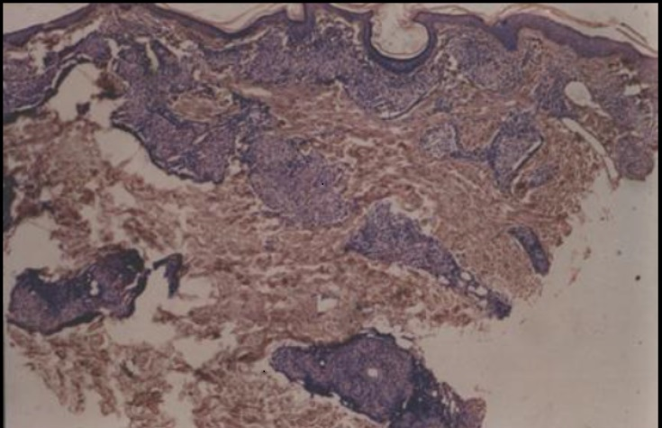

Fig 1:Tuberculoid Leprosy (TT) – Showing multiple epithelioid cell granuloma involving
superficial and deeper dermis. (H&E, 10X)

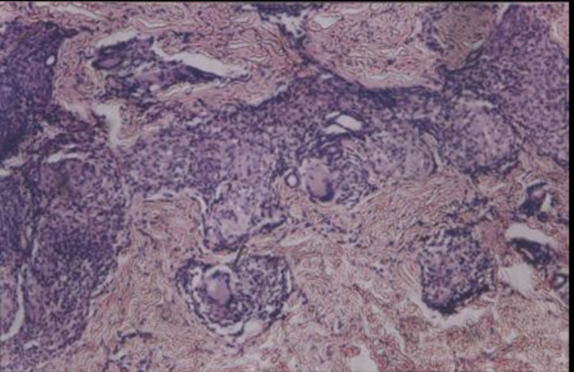

Fig 2: Borderline Tuberculoid Hansen – Showing multiple granulomas in deeper dermis along with giant cells. (H&E, 10X)

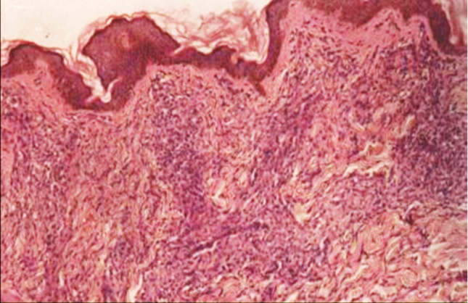

Fig 3: Borderline Tuberculoid Hansen (BTH) – Low power view showing ill formed epithelioid cell granulomas in superficial dermis with sparing of ssubepidermal zone.

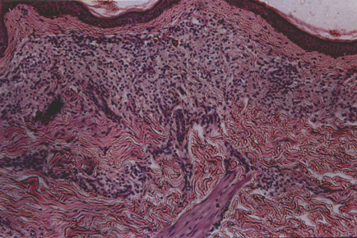
Fig 4: Lepromatous Leprosy (LL) - Higher power view showing collection of foamy macrophages in superficial dermis with thinned out epidermis. (H&E,)10X)
. (H&E, 4X)

TABLES:
Table no. 1: Distribution of 112 clinically Diagnosed Cases of Leprosy:
Sr. No. | Clinical Diagnosis | No. of Cases | Percentage (%)
1 | TT | 16 | 14.29%
2 | BTH | 48 | 42.86%
3 | BB | 4 | 3.57%
4 | BLH | 18 | 16.07%
5 | LL | 8 | 7.14%
6 | INTD | 2 | 1.79%
7 | Hansen | 11 | 9.82%
8 | Histoid | 2 | 1.79%
9 | Type I | 1 | 0.89%
10 | Type II | 2 | 1.79%
 | Total | 112 | 100.00%

Table no 2: Distribution of 112 histopathologically Diagnosed Cases of Leprosy:
Sr. No. | Histopathological Diagnosis | No. of Cases | Percentage (%)
1 | TT | 36 | 32.14%
2 | BTH | 31 | 27.68%
3 | BB | 8 | 7.14%
4 | BLH | 6 | 5.36%
5 | LL | 11 | 9.82%
6 | INDT | 14 | 12.50%
7 | Histoid | 3 | 2.68%
8 | Type I | 1 | 0.89%
9 | Type II (ENL) | 2 | 1.79%
 | Total | 112 | 100.00%

Table 3: Age wise distribution of Leprosy cases
Age | T.T | B.T.H | B.B | B.L.H | L.L | INDT | Hist | Type1 | Type2 | Total | %
0-10 | 3 | - | - | - | - | - | - | - | - | 3 | 2.67
11-20 | 5 | 9 | 3 | - | 2 | 5 | - | - | - | 24 | 21.43
21-30 | 7 | 12 | 2 | 2 | - | 2 | 1 | - | - | 26 | 23.22
31-40 | 8 | 4 | - | 1 | 5 | 4 | 2 | - | 1 | 25 | 22.32
41-50 | 7 | 1 | 1 | 2 | 2 | 1 | - | - | - | 14 | 12.51
51-60 | 3 | 4 | 1 | - | 1 | 1 | - | - | - | 10 | 8.93
61-70 | 3 | 1 | 1 | 1 | 1 | 1 | - | 1 | 1 | 10 | 8.92
Total | 36 | 31 | 8 | 6 | 11 | 14 | 3 | 1 | 2 | 112 | 100

Table 4: Correlation between Clinical Diagnosis and Histopathological Type of Leprosy and Reactions.


