Giant Apocrine Hidrocystoma of the Anogenital Region: A Case Report
Abstract
Hidrocystoma are rare, benign, cystic lesions of the sweat glands. The occurrence of such giant apocrine hidrocystoma in the anogenital region is rare. We found that there is paucity of literature regarding the apocrine hidrocystoma having atypical presentation.
Hence, herein we present the case of giant apocrine hidrocystoma measuring 2.5x2.3 cm in size located in the anogenital region in a 23-year-old male patient.
Key words: apocrine gland, hidrocystoma, adnexal neoplasm
Introduction:
Hidrocystoma are rare, benign, cystic lesions of the skin. They can be either apocrine or eccrine in origin with varying diameters of 3-15mm in size. Tumours more than 20mm are called as giant apocrine hidrocystoma. ^{[1]}
They are commonly found on head, neck and the trunk regions ^{[2]} and the rare sites of presentation are axilla, penis and anal region ^{[3]}. To the best of our knowledge there are very few case reports in the English literature on giant apocrine hidrocystoma at a rare site in the anogenital region.
Herein, we present a rare case of giant, solitary apocrine hidrocystoma of 28mm in size located in the anogenital region causing functional morbidity.

Case Report
A 23year-old-male patient presented to surgical outpatient Department with a history of swelling, located in between the anus and scrotal region since five months (figure 1).
Figure 1: solitary swelling occupying the anogenital region.

Patient presented with history of difficulty in sitting position and doing routine work. There was no history of trauma. Medical and family histories were insignificant. Local examination revealed there was a solitary swelling of 2.8x 2.5 cm in size occupying between the anus and scrotal region and was covered with skin. Fluctuation was positive. Clinical diagnosis of adnexal tumour was offered. The patient underwent en-block resection of the lesion under general anesthesia and the specimen was subjected to histopathological examination.
Pathological findings;
The gross examination of the specimen showed cyst measuring 2.5x2.3 cm with grayish white in colour. The histopathological examination of the paraffin section stained haematoxylin and eosin (Hand E) revealed presence of cyst in the dermis (figure 2).
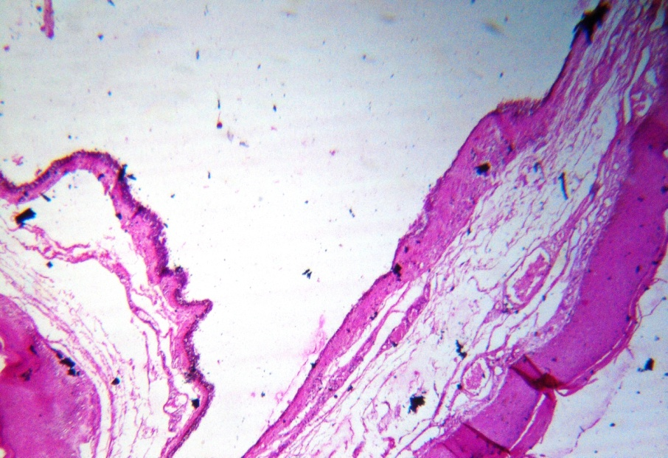
Figure 2: Hidrocystoma located in the dermis.
The cyst was lined by an inner layer of secretary columnar epithelium which lay above an outer myoepithelial cell layer (figure 3).
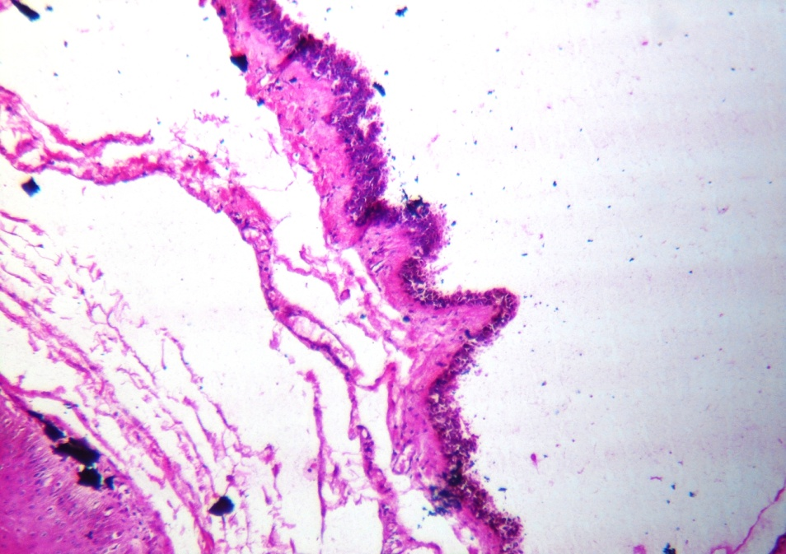
Figure 3: Cyst lined by an inner layer of secretary columnar epithelium, which lies above an outer myoepithelial cell layer (H and E, 400X).
At places, the secretary epithelium showed decapitation, which suggested the diagnosis of apocrine hidrocystoma (Figure 4).
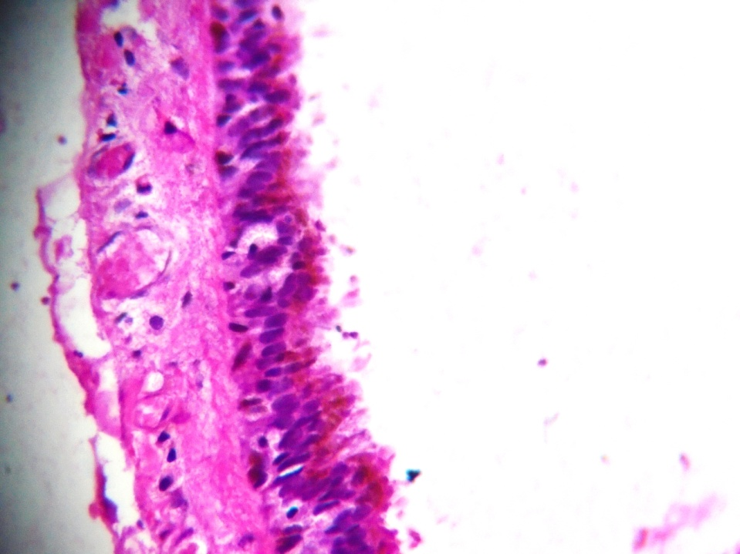
Figure 4: Cyst wall with secretary epithelial cells with apocrine snouts (H and E, 400X).

Discussion
Apocrine hidrocystoma are benign cystic tumours of the secretary portion of apocrine sweat glands, first described by Mehregan in 1964. ^{[4]} Since, most of the adnexal neoplasms exhibit a morphological differentiation towards one / more types of adnexal structures which are found in the normal skin, (pilosebaceous units, eccrine and apocrine glands) and hence, very essential to know the histomorphological features of adnexal neoplasms.
The apocrine glands are most frequently present in the axilla, the groin, the external auditory canal, and the eyelids and on the nipple. The exact stimulus for the development of an apocrine hidrocystoma is unknown. The occlusion or blockage of the sweat duct apparatus, results in the retention of sweat and a dilated cystic structure, are considered to be the causes. They are believed to be the adenomatous cystic proliferation of the apocrine gland. ^{[5]}
The literatures suggest that apocrine hidrocystoma are relatively common in the united states. There is no predilection for sex, race or geographic region for apocrine hidrocystoma. It occurs in adulthood, although there is no particular age group for its occurrence. Apocrine hidrocystoma usually are asymptomatic, no seasonal variation, familial tendencies have been identified. They grow slowly and usually persist indefinitely. ^{[2]} Patient approaches either due to cosmetic reason or functional morbidity.
Apocrine hidrocystoma may appear as single/multiple with varying diameter of 3-15mm. Tumours more than 20mm are called as giant apocrine hidrocystoma. ^{[1]}
Clinically eccrine and apocrine hidrocystoma has got similar presentation. However, the apocrine type produces oily, foamy secretions whereas eccrine type produces watery secretions. Histopathologically, apocrine hidrocystomas demonstrate multiple cystic spaces, papillary projections and an outer wall of myoepithelial cells, in contrast to eccrine hidrocystomas which have a single cystic cavity, no papillary projections and is lined by one or two layers of cuboidal epithelial cells. ^{[6]}
The other clinical differential diagnosis includes epidermal inclusion cyst, haemangioma, lymphangioma, mucoid cyst, sebaceous cyst, mollusum contagiosum and atypical basal cell carcinoma. But these lesions differ from the apocrine hidrocystoma histologically. ^{[2]}
Very often, the apocrine hidrocystoma present as blue-black coloured nodules and hence, their differentiation from melanoma and basal cell carcinoma is important. ^{[7]}
Spontaneous resolution is rare and successful management is by excision with complete cyst wall removal in order to avoid recurrence. Multiple cysts are treated with laser thermo-ablation curettage and botulinum toxin.
We have opted for en-block excision of the complete cyst and postoperatively patient doing well, with no recurrence till the date of review of the case.
To the best of our knowledge in the English literatures there are very few case reports, on a rare tumour of giant apocrine hidrocystoma located at a rare site in the anogenital region presenting with functional and cosmetic disfigurement despite its histologically benign nature. Hence, the present case has been reported for its rarity, size and its unusual presentation.
Conclusion
Although giant apocrine hidrocystoma are rare and typically asymptomatic, still they are of interest as they closely resemble serious skin disorders which include both benign and malignant conditions which have to be ruled out. Awareness of this entity helps the surgeon in decision making regarding the surgical management.

References

- Prabhu A, Prabhu M, K Niranjan1 and Grampurohit UV. Recurrent giant apocrine hidrocystoma of the eyelid: A case report. Egyptian Dermatology Online Journal 2014;10(1);10.
- Vani D, Dayananda T R, Shashidhar HB, Bharathi M, Hareesh R S Kumar, V Ravikumar. Multiple Apocrine Hidrocystomas: A Case Report. Journal of Clinical and Diagnostic Research 2013;7:171-72.
- Choudhary S, G Suba, BS Ramesh and MB Shanmukan. Hydrocystoma of eyelid: a case report. Int.J.Curr.Res.Aca.Rev 2015;3:159-61.

- Mehregan AH. Apocrine cystadenoma, a clinicopatholoical study with special reference to the pigmented variety. Arch Dermatol 1964;90: 274-79.
- Rapini RP. Apocrine Hidrocystoma. http://www.emedicine.com/derm/ topic35.htm.
- Vashi N, Mandal R. Giant multi-loculated apocrine hidrocystomas. Dermatol Online J 2010;16:16
- Shegal S, Agarwal R, Singh S, Goyal P. Fine-needle aspiration cytology of eccrine hidrocystoma. Cyto Journal. February 2012.

