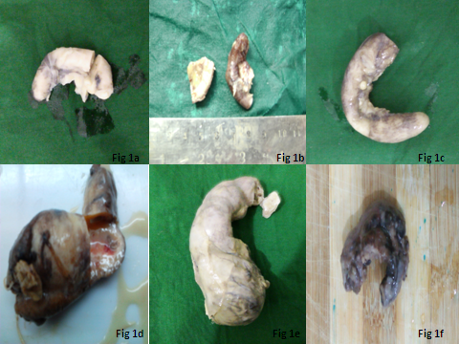 FIG 1

FIG 2

Figure legends—
Fig 1-Gross features of unusual findings in appendectomy specimens.
- Obliterative appendicitis with lumen completely obliterated by faecoliths
- Eosinophilic appendicitis also presented with fibrosed and occluded lumen
- Granulomatous appendicitis with tiny whitish tubercle on serosal aspect
- Mucocele on cut section with dilated lumen and thick wall with mucoid fluid exudation
- Diverticulum of appendix with large, dilated lumen and congested blood vessels on serosal aspect
- Carcinoid tumor at tip of appendix presented with perforative appendicitis covered with brown exudation
Fig 2-Unusual histopathological findings.
- Chronic obliterative appendicitis with fibrous obliteration and lymphocytic infiltration (H&E,x400)
- Eosinophilic appendicitis. The muscularis propria of appendix with dense and diffuse infiltration by eosinophils (H & E, x400)
- Granulomatous appendicitis. Submucosal granuloma with caseation necrosis (H & E, x400)
- Carcinoid tumor presenting ulceration of the mucosa with submucosal tumor (H & E, x100)
- Nests of uniform tumor cells with salt and paper chromatin in submucosa (H & E, x400)
- Signet ring adenocarcinoma with characteristics signet ring cells with eccentric nucleus and vacuolated cytoplasm (H & E, x400)

