TITLE PAGE
Article Details:
Type of article | CASE REPORT
Title | A rare case of leukemia cutis in T-cell acute lymphoblastic leukemia (T-ALL) in an elderly patient
Running Title | T- ALL with leukemia cutis in an elderly patient
Authors’ Details
S. No. | Author/s Names (First Name, Middle Name and Surname) | Email | Affiliation (Department and full name of institute)
1 | Dr. Anshu Gupta | dransh2002@yahoo.co.in | Associate Professor, Pathology &  In – charge, Emergency Laboratory, Institute of Human Behavior and allied Sciences, Delhi
2 | Dr. Sadhana | drsadhana07@gmail.com | Senior Resident, Emergency Laboratory, Institute of Human Behavior and allied Sciences, Delhi
3 | Dr. Tanima Dwivedi | tanimadwivedi@gmail.com | Senior Resident, Emergency Laboratory, Institute of Human Behavior and allied Sciences,Delhi
Correspondence Details
Institution to which this study is associated with | Institute of Human Behavior and allied Sciences(IHBAS),Delhi,India
Corresponding Author’s Name, Mailing Address, e-mail address and phone number with country code and area code | Dr.Anshu Gupta,Associate Professor, Emergency Laboratory,Institute of HumanBehaviour and Allied Sciences, Dilshad Garden, Delhi-110095, India. Email: dransh2002@yahoo.co.in  Mob:91-9868396812

Other Details
Total Word Count | 1912
Total No of Tables | 1
Total No of Figures: | 5
Total No of References | 26
Funding Source | Nil
Conflict of Interest (Y/N) | Nil
If Yes, Details | Not applicable

ABSTRACT
Primary cutaneous involvement in T-cell acute lymphoblastic leukemia (ALL) is rare in elderly patients. Here we present a case of 65 years old male admitted to a metropolitan tertiary care hospital because of maculo-papular lesions on chest and back for last 3 months as chief complaint along with on and off history of fever, fatigability and anorexia. On general examination, there was no lymphadenopathy. Per-abdomen examination revealed hepato-splenomegaly. CT scan of chest and abdomen showed para-tracheal, pre-tracheal, carinal, hilar and abdominal lymphadenopathy. Peripheral blood smear and bone marrow aspiration showed more than 80% of lymphoblasts. Flowcytometry of the bone marrow aspirate showed CD7, CD5, CD45 and TdT positivity indicating T–cell origin. Skin biopsy from macula-papular lesion revealed secondary leukemic infiltration of the skin. Corroborating all the above findings, a final diagnosis of T-cell ALL with leukemia cutis was made. Thereafter patient was given chemotherapy and after one month, the skin lesions started resolving and total leukocyte count (TLC) decreased. One week later, skin lesions relapsed with fall in hemoglobin and rise in TLC. Repeat bone marrow aspirate showed 90% blasts cells. Then, patient was put on palliative therapy but his condition progressively deteriorated and ultimately died within four months of diagnosis.
Keywords:
T cell, Acute lymphoblastic leukemia, Leukemia cutis, Hepato-splenomegaly

MAIN TEXT
INTRODUCTION:
Acute lymphoblastic leukemia (ALL) is a malignancy of bone marrow where normal hematopoietic cells are replaced by proliferating lymphoid precursor cells. It is the most common type of leukemia seen in pediatric age group constituting about 75% of the all cases of leukemia ^{[1]} .Incidence of ALL in elderly patients (> 65 years) is 1-1.6 per 100000 patients^{[2]} .Among all newly diagnosed cases of ALL, approximately 11.2% were from age group of >65 years. WHO classifies ALL as Pre (precursor)B-lymphoblastic ALL(most common ALL in adults), Mature B cell ALL (Burkitt ALL corresponds to ALL-L3) and Pre (precursor) T-cell ALL^{[3]}.

Leukemia Cutis (LC) is extra-medullary manifestation of leukemia caused by infiltration of skin by neoplastic leukemic cells and thus resulting in clinically identifiable skin lesions^{[4]}. Incidence of LC is more common in AML constituting 10-15% of cases as compared to chronic myeloproliferative disorders^{[5]} However LC is rare in cases of precursor B- or T-cell lymphoblastic leukemia/lymphomas (1%).
Here, we are reporting a case of T-cell acute lymphoblastic leukemia with cutaneous infiltration in an elderly, posing as a diagnostic challenge because of its unusual presentation and rare immunophenotype.

CASE REPORT:
A previously healthy 65 years old male was admitted to a metropolitan tertiary care hospital with chief complaints of fever, fatigue, anorexia, and pruritic maculo-papular lesions over chest and back for past 3 months. On clinical examination, the patient was averagely built and poorly nourished. Skin lesions were maculo-papular, erythematous, non-tender without ulceration or induration and blanching with pressure (Fig.1).There was no palpable lymphadenopathy in cervical, axillary or inguinal region. Per-abdomen examination showed enlarged liver, 3cms below costal margin and moderate splenomegaly. Biochemistry investigations showed ALT: 45 IU/L, AST: 48 IU/L, LDH: 392 IU/L, with normal kidney function tests. Ultrasonography revealed hepatosplenomegaly with liver measuring 18 cm and spleen measuring 19 cm. Chest roentgenogram and bone scan were normal. Routine hematological investigations revealed hemoglobin: 11.5g/dl and total leucocyte count (TLC): 55,500/cmm. Differential Leukocyte Count was blast cells 80%,neutrophils 10%, lymphocytes 6%,monocytes2%, eosinophils2%, basophils0%, and platelet count: 1,20,000/cmm. Leishman stained peripheral smear showed 80% of blasts which were small to intermediate in size and round with scant light-blue cytoplasm, moderately condensed to dispersed chromatin and inconspicuous nucleoli(Fig.2&3). CT scan of the chest showed right para-tracheal, pre-tracheal, carinal and bilateral hilar lymphadenopathy. CT scan of the abdomen revealed hepatosplenomegaly and discrete pre and para-aortic, and aorto-caval lymphadenopathy. Geimsa stained bone marrow aspirate smears showed more than 80% of blast cells that had characteristics of lymphoblasts. Special cytochemical stains i.e Myeloperoxidase, Periodic acid schiff and Sudan black stains were negative on bone marrow aspirate. Skin biopsy performed from one of the maculo-papular lesions showed thinned out epidermis. The dermis showed infiltration by atypical immature and blast like cells arranged in nodules, around blood vessels and adenexal structures (Fig. 4&5).These tumor cells were positive for CD45, suggestive of secondary leukemic infiltration of skin. On flowcytometry, CD7, CD5, CD45 and TdT were positive on bone marrow aspirate while CD10, HLADR, CD34 and B cell markers (CD19 and CD20) were negative. With these findings, a final diagnosis of immunologically T-cell type ALL with leukemia cutis was made. Patient was put on chemotherapy. Initially, skin lesions started resolving along with decrease in total leukocyte count (TLC) after one month of treatment but one week later, skin lesions relapsed, started appearing on post-auricular region and then spreading over to rest of the body. His hemoglobin dropped to 6gm/dl, TLC increased and bone marrow examination showed 90% of blast cells. Patient was put on palliative therapy only because of poor response. His condition started deteriorating progressively, ultimately leading to death within four months of diagnosis.

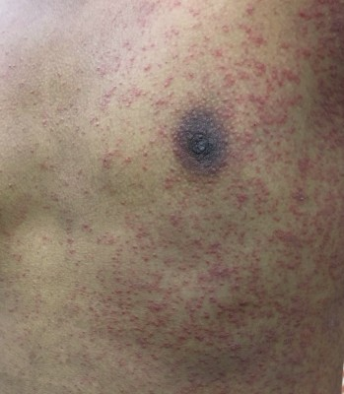
Figure 1: Photograph showing macula-papular lesions on chest of the patient

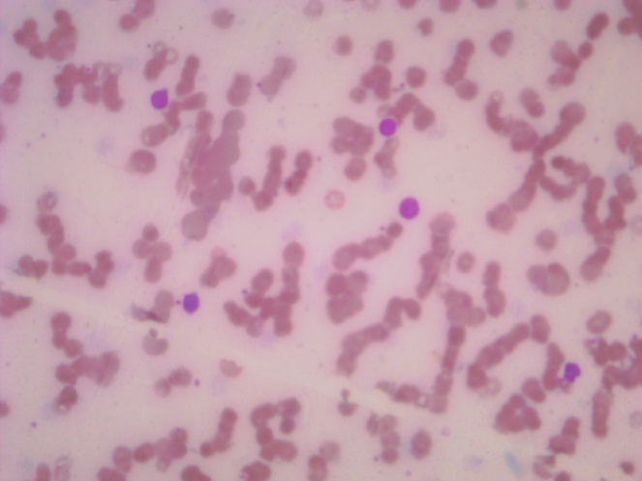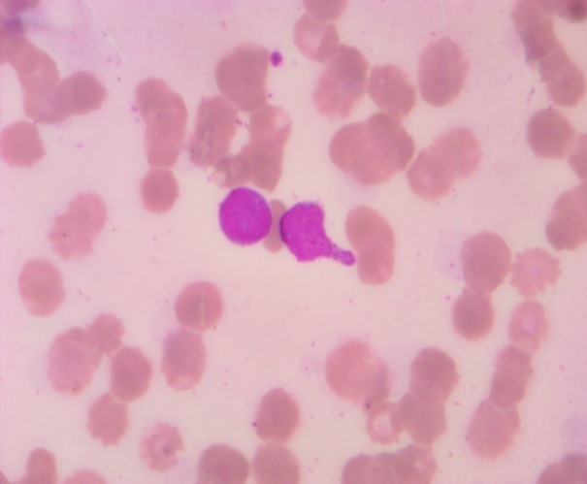
Figure 2: Microphotograph of peripheral smear showing lymphoblasts (Leishman stain x 10x )
Figure 3: Same microphotograph under higher magnification (Leishman stain x100x).

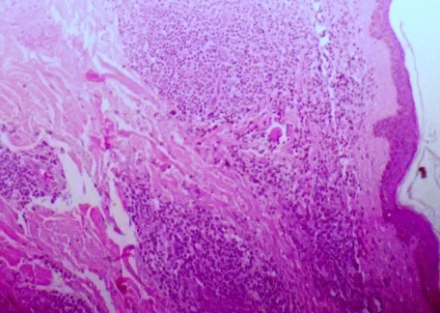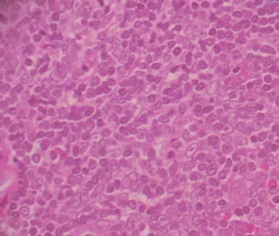
Figure 5: Same microphotograph under higher magnification showing blast like cells(H&E stain x40x)

Figure 4: Skin biopsy showing thinned out epidermis and blast like cells in nodules within the dermis (H&E stainx10x)

DISCUSSION:

ALL is most common leukemia diagnosed in younger patients and is a rare disease of elderly. There is a peak in its incidence between 2-5 years followed by falling rates during later childhood, adolescence and young adults^{[6]}. Its incidence increases again in the sixth decade and peaks in elderly patients. Its incidence in elderly patients (> 65 years) is 1-1.6 per 100000 patients while in young adults aged 25-54 years, it is 0.6-0.7 per 100000. Male/Female ratio in elderly is 267/282(0.95) while in young adults it is 1.43^{[7]}. Our patient was 65 years old male.
Clinical presentation of ALL is heterogenous. Fatigue and lethargy are frequent manifestations because of anaemia. About 50% of patients present with fever. Dermal and mucus membranes petechiae and bone tenderness may occur due to leukemic infiltration. Leukemia cutis (LC) is an extra-medullary manifestation of leukemia. It is generally seen in previously diagnosed cases of leukemia. However, rarely it may be the presenting manifestation of systemic disease^{[8]}. Clinically, LC presents with papules, plaques, or nodules with color ranging from violaceous to red-brown^{[9]}. Incidence of LC is more common in AML constituting 10-15% of cases as compared to chronic myeloproferative disorders^{[5]}. In mature T-cell leukemia it has been reported in 20-70% of cases^{[8]}. However, LC is rare in cases of precursor B- or T-cell lymphoblastic leukemia/lymphomas (1%) and plasma cell myeloma ^{[10,11,12]}. LC is associated with poor prognosis as concluded by some studies including study by Su WP (1984 )^{[13]}. Marti RM et al (2003) reported that there was no significant difference between leukemic patients with and without LC in terms of sex, age, WBC count, hemoglobin , platelet count, and fibrinogen level, however serum LDH and β2 -microglobulin had been observed to be higher in cases with LC^{[14]}. In our case, patient presented with fever, lethargy and maculo-papular lesions on skin without any petechiae or bone tenderness. Serum LDH was within normal limits.
Various studies reported varied clinical findings regarding hepatosplenomegaly, lymphadenopathy, CNS involvement and mediastinal mass in ALL. Hepatosplenomegaly and lymphadenopathy are common findings in children^{[15]} whereas half of the elderly patients do not have lymphadenopathy, hepatomegaly or splenomegaly^{[16]}as reported by Pui C-H and Crist WM (1999),Chessells et al (1998),Thomas et al (2001)etc. Another study concluded that there was no significant difference in hepatomegaly and CNS involvement between elderly patients and adults ^{[17]}.Various studies quoted 4-5% of CNS involvement in ALL patients ^{[18]}.Higher incidence of CNS involvement is seen in B-cell ALL patients ^{[19]}.While Hillard M et al (2005) have found more frequent CNS involvement in T-cell immunophenotype ^{[20]}. Our patient did not have CNS involvement.
Few studies observed that about 8% of childhood cases and 15% of adult cases present with anterior mediastinal mass [15,16]. Our case had abdominal and right para-tracheal, pre-tracheal, carinal and bilateral hilar lymphadenopathy along with hepatosplenomegaly without any mediastinal mass.
Laboratory findings suggestive of anaemia, neutropenia and thrombocytopenia are frequently seen in ALL patients. Only 12% of adult patients have leukocyte count in the range of 50,000-99,000/cmm as in our case. About 46% of adult patients have hemoglobin >10g/dl. Maximum number of elderly patients (about 71%) has > 90% leukemic blasts in the marrow. Morphologically, ALL is divided into three classes according to FAB (French-American and British) classification: L1 (70-75%). Blasts are smaller, uniform with scanty cytoplasm and inconspicuous nucleoli with coarse and homogenous chromatin. L2 (20-25%): Blasts are variable in size with greater amount of cytoplasm and prominent nucleoli, irregular nuclear membrane and finer chromatin. L3 (1-2%): Blasts are larger, have deeply basophilic cytoplasm with multiple vacuoles, stippled nuclear chromatin with prominent 1-2 nucleoli. In adults L2 morphology is seen more commonly^{[21]}. On special stains, B cell ALL shows dot and block PAS positivity while T cell ALL does not stain with it rather shows acid phosphatase positivity. In our case, on peripheral smear, blasts constituted 80% of differential count and were small to intermediate in size and round with scant light-blue cytoplasm, moderately condensed to dispersed chromatin and inconspicuous nucleoli. Myeloperoxidase and PAS staining was negative. On flowcytometry ,blast cells showed CD7, CD5, CD45 and TdT positivity on bone marrow aspirate and were negative for CD10, HLADR, CD34 and B cell markers (CD19 and CD20), Therefore, categorized as ALL- L1 and T-cell type .Elderly patients have been observed less commonly to have T-cell lineage lymphoblast^{[22]}.
On immunochemistry, another classification based upon immunological expression of surface antigen has been given in Table I^{[6]} .
Most of the studies have shown that old age is in itself an independent poor prognostic factor in ALL patients. The prognosis of older ALL patients (>60years) is not as good as of younger patients, probably due to presence of various co-morbidities in elderly patients, for example poor performance status, decreased bone marrow function^{[2]}. Elderly ALL patients with high white blood cell count is found to have poor prognosis^{[23]}. According to a study done by Su WP, LC is associated with poor prognosis ^{[13]}. But now only immunological, cytogenetic and molecular factors are considered. Study done by Gokbuget & Hoelzer (2009) quoted worse prognosis of pro-B- or pre-pre-B ALL and the immature T-cell precursor.
Additionally, since there is inadequate data from clinical trials with respect to the ALL patients with old age, probably they are not being treated by the most effective agents.
The incidence of Philadelphia (Ph) chromosome which is resistant to conventional chemotherapy increases with age and was observed in 24% of elderly patients and 19% of young patients^{[17]} and this Ph-positive status is found to be a poor prognostic factor^{[24]}.
Treatment of ALL varies from palliative care to intensive therapy. The palliative or minimally aggressive therapy (vincristine and steroids) leads to poor survival because these therapies were usually given to the patients with poor performance status ^{[25]}. It has been noticed that in elderly patients, intensive induction therapy, was frequently associated with a high mortality as compared with younger patients given similar regimen ^{[26]}. Our patient was elderly male with leukemia cutis, hepatosplenomegaly; hilar and abdominal lymphadenopathy diagnosed as T cell ALL and was put on intensive chemotherapy initially. Patient responded well in his first month course but rapidly deteriorated thereafter with abrupt fall in hemoglobin, rise in TLC and increased number of blasts in bone marrow and ultimately leading to death.

CONCLUSION:
This is the one of the rare cases of T-ALL with LC in elderly male patient. . So one should always keep acute leukemia as a differential if an elderly patient presents primarily with cutaneous manifestations along with hepatosplenomegaly even in absence of palpable lymphadenopathy. Prognosis is poor in such patients because of old age and presence of other co-morbidities.
REFERENCES:
1.Gurney JG, Davis S, Severson RK, Fang JY, Ross JA, Robison LL; Trends in cancer incidence among children in US. Cancer. 1996; 78(3):532-41.

2.Shin DY, Kim I, Kim KH ,Choi Y, Beom SH, Yang Y, Acute Lymphoblastic Leukemia in Elderly Patients: A Single Institution's Experience. Korean J Intern med. 2011; 26(3): 328-39.
3. Bathia S, Robinson L. Epidemiology of leukemia in childhood. In: Nathan DG, Orkin SH, Ginsburg D, Look AT, editors. Nathan and Oski's Hematology of Infancy and childhood. 6th ed. Philadelphia :Saunders; 2003.1081–1100.

4. Weedon D. Cutaneous infiltrates- lymphomatous and leukemic. In: Weedon D, Strutton G, editors. Skin Pathology. 2nd ed. New York:Churchill Livingstone; 2002.1118-20.

5. Agis H, Weltermann A, Fonatsch C, Haas O, Mitterbauer G, Müllauer L, et al. A comparative study on demographic, hematological, and cytogenetic findings and prognosis in acute myeloid leukemia with and without leukemia cutis. Ann Hematol.2002; 81:90-95.

6 .Pui C-H. Acute lymphoblastic lymphoma. In Beutler E, Coller B, Litchman M, Kipps TJ, editors.Williams hematology. 6thed. New York: Graw-Hill; 2001.1141-62.

7. Annino L, Vegna LM, Camera A, Specchia G, Visani G, Fioritoni G. Treatment of adult acute lympho-blasticleukemia (ALL): long-term follow-up of the GIMEMA ALL 0288 randomized study. Blood. 2002; 99: 863 - 71.
8.Cho-Vega JH, Medeiros LJ, Prieto VG, Vega F. Leukemia cutis.Am J Clin Pathol. 2008; 129(1):130-42.
9. Seymour JF, Pierce SA, Kantarjian HM, Keating MJ, Estey EH. Investigation of karyotypic, morphologic, and clinical features in patients with acute myeloid leukemia blast cells expressing the neural cell adhesion molecule (CD56). Leukemia.1994;8:823-26.
10. Yen A, Sanchez R, Oblender M, Raimer S. Leukemia cutis: Darier’s sign in a neonate with acute lymphoblastic leukemia. J Am Acad Dermatol. 1996; 34: 375-78.
11. Sander CA, Medeiros LJ, Abruzzo LV, Horak ID, Jaffe ES. Lymphoblastic lymphoma presenting in cutaneous sites: a clinicopathologic analysis of six cases. J Am Acad Dermatol. 1991;25:1023-31.
12. Ali R, Ozan U, Ozkalemkas F,Ozcelik T, Ozkocaman V, Ozturk H, Tunali S et al. Leukaemia cutis in T-cell acute lymphoblastic leukaemia. Cytopathology.2006;17:158-61.
13. Su WP, Buechner SA, Li CY. Clinicopathologic correlations in leukemia cutis. J Am Acad Dermatol.1984;11:121-8.
14. Marti RM, Pujol RM, Servitje O, Palou J, Romagosa V, Bordes R, et al. Sézary syndrome and related variants of classic cutaneous T-cell lymphoma: a descriptive and prognostic clinicopathologic study of 29 cases. Leuk Lymphoma. 2003; 44:59-69.
15. Reiter A, Schrappe M, Ludwig WD. Chemotherapy in 998 unselected childhood acute lymphoblastic leukemia patients. Results and conclusion of multicentric trial ALL-BFM 86.Blood.1994; 84:3122-33.
16.Chessells JM, Hall E, Prentice HG, Durrant J, Bailey CC, Richards SM: The impact of age on outcome in lymphoblastic leukemia; MRC UKALL X and XA compared :a report from the MRC Paediatric and Adult Working Parties. Leukemia, 1998; 12:463-73.

17.Thomas X, Olteanu N, Charrin C, Lhéritier V, Magaud JP, Fiere D. Acute lymphoblastic leukemia in the elderly: the Edouard Herriot Hospital experience. Am J Hematol.2001;67:73-83.

18. Petersdorf SH, Kopecky KJ, Head DR, Boldt DH, Balcerzak SP, Wun T. Comparison of L10M consolidation regimen to an alternative regimen including escalating methotrexate/Lasperginase for adult acute lymphoblastic leukaemia : A southwest Oncology Group Study; Leukaemia 2001;15:208-16.

19. Thomas DA, Cortes J, O Brien S, Pierce S, Faderl S, Albitar M, Hagemeister FB, et al. Hyper-CVAD program in Burkitt’s-type adult acute lymphoblastic leukemia. J Clin Oncol.1999;17: 2461-70.

20. Hillard M, Lazarus, Susan M, Richards, Chopra R, Mark R, Litzow. Central nervous system involvement in adults in adult acute lymphoblastic leukemia at diagnosis: results from the international ALL trial MRC UKALL XII/ECOG E2993. Blood. 2006 ;108:465-72.

21.Arora RS, Eden TOB, Kapoor G. Epidemiology of childhood cancer in India. Indian Journal of Cancer 2009;46(4):264-73.

22. Delannoy A, Sebban C, Cony-Makhoul P,Cazin B,Cordonnier C,Bouabdallah R. French Group for Treatment of Adult Acute Lymphoblastic Leukemia. Age-adapted induction treatment of acute lymphoblastic leukemia in the elderly and assessment of maintenance with interferon combined with chemotherapy: a multicentric prospective study in forty patients. Leukemia.1997;11:1429–34.

23. Annino L, Goekbuget N ,Delannoy A. Acute lymphoblastic leukemia in the elderly. The Hematology Journal .2002; 3: 219-23.

24. Thomas X, Thiebaut A, Olteanu N, Danaïla C, Charrin C, Archimbaud E. Philadelphia chromosome positive adult acute lymphoblastic leukemia: characteristics, prognostic factors and treatment outcome. Hematol Cell Ther.1998;40:119–28.

25.Taylor PRA, Reid MM, Bown N, Hamilton PJ, Proctor SJ. Acute lymphoblastic leukemia in patients aged 60 years and over: a population-based study of incidence and outcome. Blood.1992; 80: 1813-17.

26.Kantarjian HM, O'Brien S, Smith TL, Cortes J, Giles FJ, Beran M, Pierce S, et al. Results of treatment with hyper-CVAD, a dose-intensive regimen, in adult acute lymphocytic leukemia. J Clin Oncol.2000; 18: 547-61.

Table I: Immunological classification– Based upon expression of surface antigen
S.No. | Type | Characterstics | Immunocytochemistry
1. | Pro-B ALL | Accounts 10% cases of ALL,seen commonly in infants and children, morphologically correlates with FAB- L1 and L2 | HLA-DR+,  TdT+
2. | Early- pre B ALL (Common ALL) | comprises 2/3rd of childhood ALL cases, most cases are CALLA (CD 10) positive | HLA-DR+,  TdT+,CD10+
3. | Pre-B ALL | 20% of childhood ALL cases, express cIg, which is associated with t(1;19) and poorer outcome | HLA-DR+,  cIg +
4. | Mature B-cell ALL | Rare (1-2%), morphology is FAB-L3, poor prognosis | SIg, λ +, κ +
5. | T-ALL | 15-20% of ALL cases, have morphology of L1 and L2, PAS negative, Acid phosphatase positive, Higher incidence of CNS involvement, associated with mediastinal mass | CD3+, CD 2+ CD5+, CD7+, TdT+
6. | Mixed lineage acute leukemia | Comprises 1-2% of acute leukemia, two populations of morphologically and immunophenotypically distinct cell, Larger cells with myeloblastdifferentiation , MPO +, SBB +, usually with Auer rods or wit monoblastic morphology. Smaller blasts with L1 morphology. Blast express myeloid and lymphoid antigens | CD3+,CD79a+, CD22+,CD10+, TdT+, MPO+, CD13+, CD11b+
7. | Undifferentiated acute leukemia | Blast have L2 morphology but no lineage differentiation | HLA-DR+,CD-34+, TdT+,CD-38+,CD-7+
cIg-cytoplasmic immunoglobulin; sIg-surface immunoglobulin; TdT-terminal deoxynecleotidyltransfarase.

