LETTER TO EDITOR
TITLE PAGE
TITLE – Atrial Septal Defect-Management Approach In Children
AUTHOR
Dr Suraj Wasudeo Nagre
M.B.B.S,M.S,M.Ch C.V.T.S, D.N.B. C.V.T.S.
Associate Professor ,Department of CVTS
Grant Medical College,Mumbai
Email - surajnagre@yahoo.com
Mobile no -09967795303

Correspondence Address
Dr Suraj Wasudeo Nagre
31,Trimurti Building,J J Hospital compound,
Byculla , Mumbai, Pin -400008
Email - surajnagre@yahoo.com
Mobile no -09967795303

Conflict of interest-no potential conflicts of interest
Funding- no funding was provided
Keywords-Atrial septal defect,
Device closure

Atrial septal defect is usually an asymptomatic disease. However, children with atrial septal defects are at increased risk for several complications, such as endocarditis (if associated mitral valve insufficiency is present) and respiratory tract infections. Any individual with an atrial level shunt is at risk for a paradoxical embolus from a venous thrombus, but in children, this is exceedingly rare, unless there is an underlying hypercoagulable state. Children with clinically significant and untreated atrial septal defects are at risk for various cardiac complications, including CHF, pulmonary hypertension, and arrhythmias treated with diuretics, afterload reduction, and digoxin. Medical therapy is of no benefit in children with asymptomatic atrial septal defects (ASDs).
With the exception of ostium secundum types, atrial septal defects are structural defects that do not spontaneously close. Occasionally, small primum ASDs may not require closure, but due to their association with mitral valve abnormalities, they may be closed at the time of mitral valve repair, if such a repair is indicated. An ostium secundum atrial septal defect that measures 6 mm in diameter or smaller in the patient's first year of life is likely to spontaneously close. Definitive therapy for an atrial septal defect has historically been limited to surgical closure. However, with the advent of transcatheter techniques, many children undergo successful treatment in the cardiac catheterization laboratory.
Transcatheter approaches to atrial septal defect closure are well accepted in the pediatric population[ Figure 1 ]. Secundum atrial septal defects are currently the only subtype of atrial septal defect that are amenable to this approach. The preference for timing of catheter-based closure is institution/interventionalist specific, but generally around age 4-6 years with a known, hemodyanmically significant defect. Benefits of the transcatheter approach include its minimal invasiveness, the lack of median sternotomy, the avoidance of cardiopulmonary bypass, and the relatively quick recovery time. Potential drawbacks and concerns include residual shunting around the device, embolization during placement requiring surgical intervention, lack of adequate septal rims to properly seat the device and the need for specific technical expertise and equipment.
The most common surgical approach to the defect is primary repair with suture closure or with patch repair (generally with glutaraldehyde treated autologous pericardium, Gore Tex patch or fabric made of polyester fiber )[ Figure 2 ]. Candidates for surgery are children with clinically significant left-to-right shunting and whose defects are not amneble for device closure.. The prognosis for a child with an atrial septal defect is good; the rate of surgical mortality is less than 1%.
Newer, minimally invasive surgical techniques like minithoracotomy,ministernotomy are developed. These improve cosmetic appearances and decrease hospital stays. These techniques are ideally suited for simple closure of a secundum atrial septal defect.^{[1]} Overall however, the medium- to long-term outcomes of ASD closure, either surgically or percutaneously, appear very good.^{[2]}

References
- Vida VL, Padalino MA, Boccuzzo G, Veshti AA, Speggiorin S, Falasco G. Minimally invasive operation for congenital heart disease: a sex-differentiated approach. J Thorac Cardiovasc Surg. 2009 Oct. 138(4):933-6. [Medline].
- Kutty S, Hazeem AA, Brown K, Danford CJ, Worley SE, Delaney JW, et al. Long-term (5- to 20-year) outcomes after transcatheter or surgical treatment of hemodynamically significant isolated secundum atrial septal defect. Am J Cardiol. 2012 May 1. 109(9):1348-52. [Medline].
Figure 1 –Transcatheter device closure of atrial septal defect
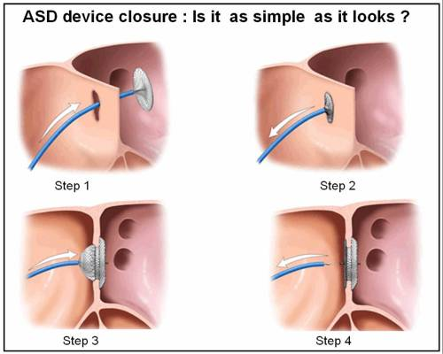
Figure 2 – Surgical approach either primary repair with suture closure or with patch repair (generally with glutaraldehyde treated autologous pericardium, Gore Tex patch or fabric made of polyester fiber [Dacron]).

